Title Page
Title:
A Route-Scale Framework for Assessing Artificial Light at Night Exposure Along Migratory Bird Routes Using Tracking Data and NASA Black Marble
Authors:
Xingyu Xue^{a,†}, Liangxin Bi^{a,†}, Liuchang Xuª, Chao Wu^{b}, Cheng Tongª, Wenjing Zhang^{a,*}, Xinyu Zheng^{a,*}
Affiliations:
ª Zhejiang A&F University, No. 666 Wusu Street, Lin'an District, Hangzhou, Zhejiang 311300, People's Republic of China
^{b} Hunan Global Messenger Technology Co., Ltd., Room 1004, Building B2, Huanchuang Enterprise Plaza, 2450 Yuelu West Avenue, High-tech Zone, Changsha City, Hunan Province, People's Republic of China
Author email addresses:
Xingyu Xue: xyxue@zju.edu.cn
Liangxin Bi: 2025611011002@stu.zafu.edu.cn
Liuchang Xu: xuliuchang@zafu.edu.cn
Chao Wu: market@hqxs.net
Cheng Tong: chengton@zju.edu.cn
Wenjing Zhang: wjz@zafu.edu.cn
Xinyu Zheng: zhengxinyu@zju.edu.cn
† These authors contributed equally to this work and share first authorship.
* Corresponding authors:
Xinyu Zheng, Zhejiang A&F University, No. 666 Wusu Street, Lin'an District, Hangzhou, Zhejiang 311300, People's Republic of China. Email: zhengxinyu@zju.edu.cn. Tel: +86-571-6373-2771.
Wenjing Zhang, Zhejiang A&F University, No. 666 Wusu Street, Lin'an District, Hangzhou, Zhejiang 311300, People's Republic of China. Email: wjz@zafu.edu.cn. Tel: +86-571-6373-2771.

A Route-Scale Framework for Assessing Artificial Light at Night Exposure Along Migratory Bird Routes Using Tracking Data and NASA Black Marble
【Original English】
Abstract: Artificial light at night (ALAN) is an increasingly important disturbance for migratory birds, yet exposure is rarely quantified jointly for stopover habitats and movement corridors along observed routes. We developed a route-scale framework integrating two-year tracking data (>17,000 fixes) from a single adult male Common Crane (Grus grus), temporal density-based spatial clustering (T-DBSCAN), kernel-density corridor extraction and NASA Black Marble VNP46A4 nighttime-light data. Habitat-use units were classified as breeding, wintering, key stopover or temporary stopover sites. Habitat exposure was assessed using coverage, standardized light-pollution, high-exposure and exposure-level metrics, while corridors were evaluated using a probability-weighted expected ALAN exposure index. We identified 18 habitat-use units: one breeding site, one wintering site, six key stopover sites and ten temporary stopover sites. Key stopover sites showed higher ALAN coverage, standardized pollution and exposure-level scores than temporary stopover sites, and one key stopover had complete ALAN coverage and the highest standardized exposure. At the corridor scale, the 50% core corridor had higher expected ALAN exposure (1.1667) than the 75% and 95% corridors (1.0171 and 0.9840), indicating stronger overlap between repeated route use and brighter nocturnal landscapes. This framework can help identify habitat nodes and route bottlenecks for targeted ALAN management; however, the results should be interpreted as an individual-level route assessment rather than population-level inference.
【Revised English】
Abstract: Artificial light at night (ALAN) is an important disturbance for migratory birds, yet residence and transit exposure are rarely quantified jointly along observed routes. We developed a route-scale framework integrating two-year tracking data (>17,000 fixes) from one rescued adult male Common Crane (Grus grus), temporal density-based spatial clustering (T-DBSCAN), kernel-density corridors, and NASA Black Marble VNP46A4 radiance. Eighteen habitat-use units were identified: one breeding site, one wintering site, six key stopovers, and ten temporary stopovers. Habitat exposure was described using pollution coverage rate (PCR), standardized habitat nighttime-light pollution index (STDHNLPI), high-exposure ratio (HER), and exposure level score (ELS), whereas corridors were evaluated using probability-weighted expected radiance (CEq). Key stopovers had greater PCR and STDHNLPI than temporary stopovers in exact permutation tests, whereas conditional ELS within ALAN-covered areas and HER showed no clear group differences. Habitat rankings were stable under ±20% radiance-threshold changes and alternative concave or convex ordinal score functions: STDHNLPI rank correlations with the baseline were 0.989–1.000 for threshold changes and 0.996–0.998 for score changes, with a maximum rank shift of two positions. Across the 2022–2024 annual composites, CEq consistently decreased from the 50% core corridor to the 75% and 95% corridors. Because the study uses one rescued individual and annual composites at nominal approximately 500-m resolution, results represent an individual-route exposure assessment rather than population-level selection or causal effects. The workflow provides a reproducible screening framework for identifying candidate habitat nodes and movement bottlenecks for field verification and ALAN management.
Keywords: animal tracking; habitat-use unit; migration corridor; artificial light at night; Common Crane

1 Introduction
Artificial light at night (ALAN) has become one of the most widespread environmental disturbances associated with human activities (Longcore and Rich, 2004). Unlike many local environmental disturbances, ALAN can alter natural circadian rhythms and reshape the nocturnal visual environment, thereby exerting cross-scale effects on highly mobile organisms such as migratory birds. Global-scale studies have shown that both the radiance and spatial extent of ALAN continue to increase. Meanwhile, the development of nighttime-light remote-sensing products now makes it possible to quantify these changes over long time series and large spatial extents (Falchi et al., 2016; Kyba et al., 2017; Levin et al., 2020; Longcore and Rich, 2004; Román et al., 2018; Z. Wang et al., 2022). Therefore, ALAN is no longer merely an issue in urban ecology, but also an important environmental factor that should be considered jointly in migration ecology, landscape ecology, and conservation biology.
【Original English】
Birds are particularly sensitive to ALAN because many aspects of their behavior and life history are regulated by natural light–dark cycles. Experimental and field studies have shown that ALAN can alter the timing of dawn singing, reproductive timing, daily activity patterns, sleep behavior, and breeding behavior in birds, and may reshape their habitat-use patterns (Beaugeard et al., 2024; Foppen et al., 2024; Matics et al., 2025; McLaren et al., 2018; Sanders et al., 2021; Van Doren et al., 2017). For migratory birds, migration connects breeding grounds, stopover sites, and wintering grounds, making the effects of night lighting more complex, meaning that individuals may experience different landscape contexts and ALAN environments at different stages of the annual cycle (Burt et al., 2023). Because the landscape context and ALAN environment differ substantially among migratory stages, ALAN may attract birds or trigger avoidance, disturbance responses, and it can also contribute to disturbance, disorientation, and increased mortality risk (Horton et al., 2023; Sanders et al., 2023). A deeper understanding of the spatial patterns of ALAN exposure along migratory routes is therefore essential.
【Revised English】
Birds are particularly sensitive to ALAN because many aspects of their behavior and life history are regulated by natural light-dark cycles. Experimental and field studies show that ALAN can alter vocal activity, reproductive timing, daily activity, sleep, breeding behavior, and habitat use (Beaugeard et al., 2024; Foppen et al., 2024; Matics et al., 2025; McLaren et al., 2018; Sanders et al., 2021; Van Doren et al., 2017). For migrants, the annual cycle links breeding, stopover, transit, and wintering environments, so the intensity and ecological meaning of exposure may change among stages (Burt et al., 2023). At different spatial scales, ALAN has been associated with attraction or avoidance, disorientation, altered movement, aggregation, and increased collision or mortality risk (Hirschhofer et al., 2026; Horton et al., 2023; Sanders et al., 2023). These responses are species-, context-, and intensity-dependent; therefore, examining the spatial overlap between migratory activity and nighttime radiance is essential for assessing potential exposure to ALAN.
【Original English】
Stopover sites are key ecological nodes during bird migration because migrants use them to rest, replenish energy reserves, and reduce exposure to adverse weather. Therefore, stopover quality can influence migration speed, survival, and overall migration efficiency (Schmaljohann and Eikenaar, 2017; Schmaljohann et al., 2022). Existing ALAN studies on migratory birds have mainly developed along several spatial scales. At the regional scale, weather-radar and remote-sensing studies have linked ALAN with broad patterns of migrant stopover distribution. For example, migrant stopover density in the northeastern United States increased with proximity to the brightest areas at the regional scale, but decreased within a few kilometers of local bright sources (McLaren et al., 2018). At a broader scale, skyglow has also been identified as a consistently positive predictor of bird migration stopover density across the contiguous United States (Horton et al., 2023). At the local or site scale, studies of specific illuminated structures and urban lighting installations have shown that intense ALAN can concentrate, disorient, and alter the movement behavior of nocturnally migrating birds (Van Doren et al., 2017). In addition, a smaller body of research has considered ALAN from the perspective of movement connectivity and corridors, showing that artificial light and urbanization may reduce the functional connectivity of nocturnal aerial habitat and that connected dark areas should be incorporated into ecological network planning (Korpach et al., 2022; Sordello et al., 2022). However, these studies have generally treated stopover distribution, local light responses, and corridor connectivity separately. Few studies have integrated tracking-derived habitat-use units and graded migration corridors within the same observed migration route to quantify ALAN exposure at both habitat and corridor scales.
【Revised English】
Stopover sites are key ecological nodes during migration because birds use them to rest, replenish energy reserves, and reduce exposure to adverse weather; consequently, stopover quality can influence migration speed, survival, and overall migration performance (Schmaljohann and Eikenaar, 2017; Schmaljohann et al., 2022). Existing ALAN research has developed along several largely separate spatial scales. Regional radar and remote-sensing studies have related ALAN to broad stopover distributions, with migrant density increasing near bright regions at broad scales but sometimes declining close to intense local sources (Horton et al., 2023; McLaren et al., 2018). Local studies of illuminated structures and low-level coastal light patches have documented concentration, disorientation, and altered flight behavior (Hirschhofer et al., 2026; Van Doren et al., 2017). Connectivity studies have further shown that urbanization and ALAN can reduce the functional connectivity of nocturnal aerial habitat and have motivated the protection of connected dark infrastructure (Korpach et al., 2022; Sordello et al., 2022). However, stopover exposure, local behavioral responses, and corridor connectivity are commonly analyzed separately. Few studies have quantified both tracking-derived habitat-use units and graded movement corridors within the same observed route, using metrics suited to the different ecological meanings of residence and transit exposure.
Advances in animal trajectory processing and trajectory analysis have provided new ways to transform raw high-frequency tracking fixes into ecologically meaningful units, such as stopover sites, habitat-use units, and repeated route-use patterns, for subsequent ALAN exposure assessment(Alavi et al., 2022; Demšar et al., 2021; Gupte et al., 2022). Researchers have applied mature trajectory preprocessing, trajectory segmentation, and route-reuse analysis frameworks from movement ecology to extract behaviorally meaningful units from high-frequency animal tracking data(Alavi et al., 2022; Demšar et al., 2021; Fischer, 2024; Gupte et al., 2022; Koger et al., 2023). Although trajectory segmentation, spatiotemporal clustering, and route-reuse analysis have been widely applied in human mobility, transportation, and animal movement studies(Alavi et al., 2022; Demšar et al., 2021; D. Wang et al., 2020; Zheng, 2015), their application to migratory birds remains constrained by the availability of long-term, high-frequency tracking data(Bridge et al., 2011; Iverson et al., 2023; Scarpignato et al., 2023). Recent advances in satellite-tracking devices(Baert et al., 2018; Gould et al., 2024; J. Li et al., 2023), including hourly positioning over extended periods, now make it possible to identify stopover behavior and repeated route-use patterns at finer temporal and spatial resolutions. In this context, satellite-tracking studies of crane species have increasingly clarified migration routes, habitat-use patterns, and seasonal movement patterns(An and Guo, 2025; Erdenechimeg et al., 2023; Pearse et al., 2021; Vanausdall et al., 2025; Wen et al., 2026).
In parallel, remote-sensing products provide essential environmental information for interpreting movement trajectories and assessing exposure along migration routes. NASA’s Black Marble nighttime lights products, through moonlight correction, atmospheric correction, and temporal compositing, provide annual nighttime-light radiance data that are more suitable for ecological exposure studies(T. Li et al., 2022; Román et al., 2018; Z. Wang et al., 2022). Sentinel-2-based 10 m land use/land cover products have substantially improved the spatial precision of habitat background interpretation and can be used to help validate the plausibility of trajectory-clustering results(Benhammou et al., 2022; Brown et al., 2022; Xu et al., 2024; Zhang et al., 2025). Together, these products make it possible to link tracking-derived habitat-use units and migration corridors with both ALAN exposure and land-cover context.
【Original English】
Nevertheless, existing research still has two important limitations. First, in habitat-use identification, traditional clustering algorithms such as DBSCAN are mainly based on point density and are sensitive to sampling frequency; they do not explicitly account for temporal continuity or minimum residence duration. For migratory bird tracks, using only a point-count threshold may misclassify short-term high-frequency sampling segments or segments affected by missing data as stopover sites(He et al., 2025). Although spatiotemporal clustering approaches have been applied to identify local habitat-use areas or stopover sites in bird-tracking studies, few studies have further distinguished key stopover sites from temporary stopover sites or linked these habitat-use categories with graded migration corridors and remotely sensed ALAN exposure along the same migratory route (Birant and Kut, 2007; He et al., 2025; K. Wang et al., 2023). Second, previous studies on the ecological effects have commonly used mean radiance to characterize ALAN exposure(Adams et al., 2024; Levin et al., 2020; Sung, 2022). However, this single-value metric may obscure differences between “large-area low light” and “small-area high light,” and cannot reflect the internal composition of exposure classes within habitats. Therefore, an integrated indicator system is needed to simultaneously account for exposure extent, exposure level, and internal structure. (Ditmer et al., 2021; Gaston et al., 2021).
【Revised English】
The present study addresses four methodological gaps. First, conventional DBSCAN-type approaches are driven mainly by spatial point density and a minimum point count; under uneven sampling, they may confuse short, densely sampled segments with biologically meaningful residence periods unless temporal continuity and minimum elapsed duration are explicitly incorporated (Birant and Kut, 2007; He et al., 2025; K. Wang et al., 2023). Second, mean radiance alone cannot distinguish broad low-intensity exposure from localized high-intensity exposure, although these structures imply different monitoring and management priorities (Ditmer et al., 2021; Gaston et al., 2021; Levin et al., 2020; Sung, 2022). Third, the robustness of class-based exposure indices should be tested against alternative radiance thresholds and continuous radiance statistics, while corridor exposure should be tested against alternative annual light backgrounds. Fourth, protected-species tracking frequently yields a small number of long, information-rich individual records rather than a large sample of complete annual tracks (Bridge et al., 2011; Scarpignato et al., 2023). A useful framework should therefore extract transparent route-level information from rare individual tracks while keeping individual-route inference distinct from population-level utilization distributions.

【Original English】
The Common Crane (Grus grus) is listed as a Class II nationally protected wild animal in China under the List of State Key Protected Wild Animals (National Forestry and Grassland Administration and Ministry of Agriculture and Rural Affairs, 2021) and is a typical large migratory waterbird whose annual cycle spans breeding grounds, migratory stopover sites, and wintering grounds(Erdenechimeg et al., 2023). This dependence on spatially separated seasonal habitats makes migratory waterbirds such as the Common Crane sensitive to migratory connectivity and stopover-site quality.(Schmaljohann et al., 2022). Therefore, the Common Crane provides a suitable case for examining how ALAN exposure is distributed across habitat-use units and migration corridors along a tracked migratory route(Horton et al., 2023; McLaren et al., 2018).
【Revised English】
The Common Crane (Grus grus) is listed as a Class II nationally protected wild animal in China (National Forestry and Grassland Administration and Ministry of Agriculture and Rural Affairs, 2021). Capture of nationally protected wildlife for scientific research is subject to special authorization under Chinese wildlife-protection law, whereas no special hunting permit is required for the bona fide rescue of injured or distressed wildlife by authorized rescue institutions. (Standing Committee of the National People's Congress of the People's Republic of China, 2022). Common Cranes are large migratory waterbirds that use spatially separated breeding, stopover, and wintering areas and commonly migrate or winter in social groups (Erdenechimeg et al., 2023). These characteristics make a long-duration rescued-individual track valuable for developing and testing an individual-route workflow under realistic data scarcity. Gregarious behavior makes the route potentially relevant for locating candidate socially used areas, but it does not provide biological replication or justify flock- or population-level inference.
【Original English】
This study proposes a new integrated framework linking habitats and migration corridors along the tracked Common Crane migration route to ALAN patterns by classifying habitat-level ALAN exposure and quantifying probability-weighted ALAN exposure across nested migration corridors. The specific objectives are to: (1) identify and classify the breeding site, wintering site, key stopover sites, and temporary stopover sites based on T-DBSCAN; (2) extract 50%, 75%, and 95% high-use migration corridors based on kernel density estimation and volume percentile thresholds; and (3) compare ALAN exposure patterns among habitat types and corridor levels using a multi-indicator system. We hypothesize that key stopover sites and temporary stopover sites differ systematically in both the intensity and structure of ALAN exposure, and that core and peripheral migration corridors differ in probability-weighted ALAN exposure. Through this work, we aim to provide a reproducible and extensible route-scale methodological framework for assessing potential ALAN exposure and identifying potential priority areas for ALAN management along migratory bird routes.
【Revised English】
Accordingly, this study develops a reproducible individual-route framework linking tracking-derived habitat-use units and nested migration corridors with NASA Black Marble ALAN patterns. The objectives were to: (1) identify breeding, wintering, key stopover, and temporary stopover units using T-DBSCAN and explicit residence-duration rules; (2) extract 50%, 75%, and 95% high-use corridors from a kernel-density migration-intensity surface; (3) compare habitat and corridor ALAN exposure using scale-appropriate complementary metrics; (4) test the robustness of habitat-exposure rankings to ±20% radiance-threshold changes and alternative ordinal score functions; and (5) evaluate corridor CEq across the 2022, 2023, and 2024 annual VNP46A4 backgrounds.

2 Study Area and Data
The study area comprises the main spatial domain covered by the tracked Common Crane migration route in Northeast Asia [110°-155°E, 30°-55°N]. This region spans multiple landscape types, including remote areas with relatively low human activity, important wetlands and protected areas, agricultural landscapes, river-lake systems, and urban and peri-urban areas with pronounced night lighting. This marked landscape heterogeneity provides an appropriate spatial context for comparing differences in ALAN exposure among habitat-use units and migration corridors.
【Original English】
The study used three types of data. The first was Common Crane tracking data obtained from a leg-ring tracker using BDS positioning and CAT1-GSM communication. The tracked individual was an adult male Common Crane rescued during migration in Lindian County, Daqing City, Heilongjiang Province, China, and was subsequently fitted with an HQLG4021S leg-ring tracker provided by Hunan Global Messenger Technology Co., Ltd., Changsha, China, before release. The resulting nearly two-year tracking dataset spanned the period from 12 October 2022 to 18 October 2024 and contained more than 17,000 location fixes across the breeding, migratory stopover, and wintering phases. With a sampling interval of approximately 1 h for most periods, the dataset provides sufficient temporal resolution for spatiotemporal clustering analysis based on stop duration. Because Common Cranes often migrate and winter in flocks, this long-term individual track may provide useful insight into route-level stopover structure and ALAN exposure patterns; however, it should be interpreted as an individual-level route representation rather than a population-level utilization pattern (Erdenechimeg et al., 2023). 【Revised English】
The study used three types of data. The first comprised Common Crane tracking locations obtained from a leg-ring tracker using BDS positioning and CAT1-GSM communication. The tracked bird was an adult male rescued during migration in Lindian County, Daqing City, Heilongjiang Province, China. After rescue and clinical assessment, it was fitted with an HQLG4021S leg-ring tracker provided by Hunan Global Messenger Technology Co., Ltd., Changsha, China, and released; no wild Common Crane was captured solely for this study. The record spanned 12 October 2022 to 18 October 2024 and contained more than 17,000 fixes covering breeding, migration, stopover, and wintering phases, with an approximately hourly interval during most periods. Opportunities to expand the sample were limited to authorized rescue or separately permitted research events, and other rescued migratory birds available to the project did not provide a complete annual cycle. This track was therefore selected because it was the only available record with two complete annual cycles and sufficient temporal resolution for residence-duration clustering. The inferential unit is the observed route of this individual. Although Common Cranes are gregarious during migration and wintering, flock membership was not independently recorded, so the track is not treated as a flock- or population-level replicate.
The second dataset was the Sentinel-2 10 m Land Use/Land Cover Time Series product. This dataset was used to support the ecological interpretation of identified habitat-use clusters by examining whether they corresponded to land-cover types such as water bodies, flooded vegetation, cropland, forest, or grassland. Previous studies have shown that the new generation of 10 m global land-cover products provides finer spatial detail than traditional medium- and low-resolution datasets (Benhammou et al., 2022; Brown et al., 2022; Xu et al., 2024; Zhang et al., 2025).
【Original English】
The third dataset was the NASA Black Marble VNP46A4 annual nighttime lights product for 2023. This product provides annual composite nighttime-light radiance data corrected for moonlight and atmospheric effects, with a spatial resolution of 15 arc-seconds, approximately 500 m, making it suitable for comparing ALAN exposure along migration routes across large areas(Román et al., 2018; Z. Wang et al., 2022; Zhang et al., 2025). A preliminary comparison of the annual nighttime-light data from 2022 to 2024 showed no obvious change in the overall spatial pattern of ALAN within the study area, Therefore, the 2023 VNP46A4 annual composite was selected as a consistent ALAN background for comparing exposure among habitat-use units and migration corridors. The data sources used in this study and their main characteristics are summarized in Table 1.
【Revised English】
The third dataset comprised NASA Black Marble VNP46A4 annual nighttime-light products for 2022, 2023, and 2024. VNP46A4 provides yearly moonlight- and atmosphere-corrected radiance composites on a 15 arc-second grid (nominally approximately 500 m). The 2023 composite was used as the baseline because it lies within the central portion of the tracking period and provides a single spatially consistent background for the principal habitat and corridor comparisons. The 2022 and 2024 composites were retained for annual sensitivity analysis of corridor$CE_{q}$. Each raster value represents an annual area-integrated radiance background rather than point-scale illuminance, spectral composition, or the exact lighting condition at a GPS timestamp. Data sources and analytical roles are summarized in Table 1.
Table 1. Data sources and their main characteristics.
【Original English】
Dataset | Use | Resolution | Description
Common Crane BDS/CAT1-GSM trajectories | Reconstruction of migration routes, habitat-use unit identification, and extraction of flight segments | Approx. 1 h | Individual track covering the breeding-migration-wintering phases
Sentinel-2 10 m land use/land cover time-series data | Assist interpretation of habitat environmental backgrounds and evaluate clustering plausibility | 10 m | Annual land-cover layers
NASA Black Marble VNP46A4 | Assessment of ALAN exposure in habitats and corridors | 15 arc-seconds (approx. 500 m) | Annual moonlight-corrected nighttime light composite product
【Revised English】
Dataset | Use | Resolution | Description
Common Crane BDS/CAT1-GSM trajectories | Reconstruction of migration routes, habitat-use unit identification, and extraction of flight segments | Approx. 1 h | Individual track covering the breeding-migration-wintering phases
Sentinel-2 10 m land use/land cover time-series data | Assist interpretation of habitat environmental backgrounds and evaluate clustering plausibility | 10 m | Annual land-cover layers
NASA Black Marble VNP46A4 (2022-2024) | Baseline ALAN assessment and annual sensitivity analysis | 15 arc-seconds (approx. 500 m) | Annual moonlight- and atmosphere-corrected nighttime-light composites; 2023 baseline, 2022 and 2024 sensitivity backgrounds

3 Methods
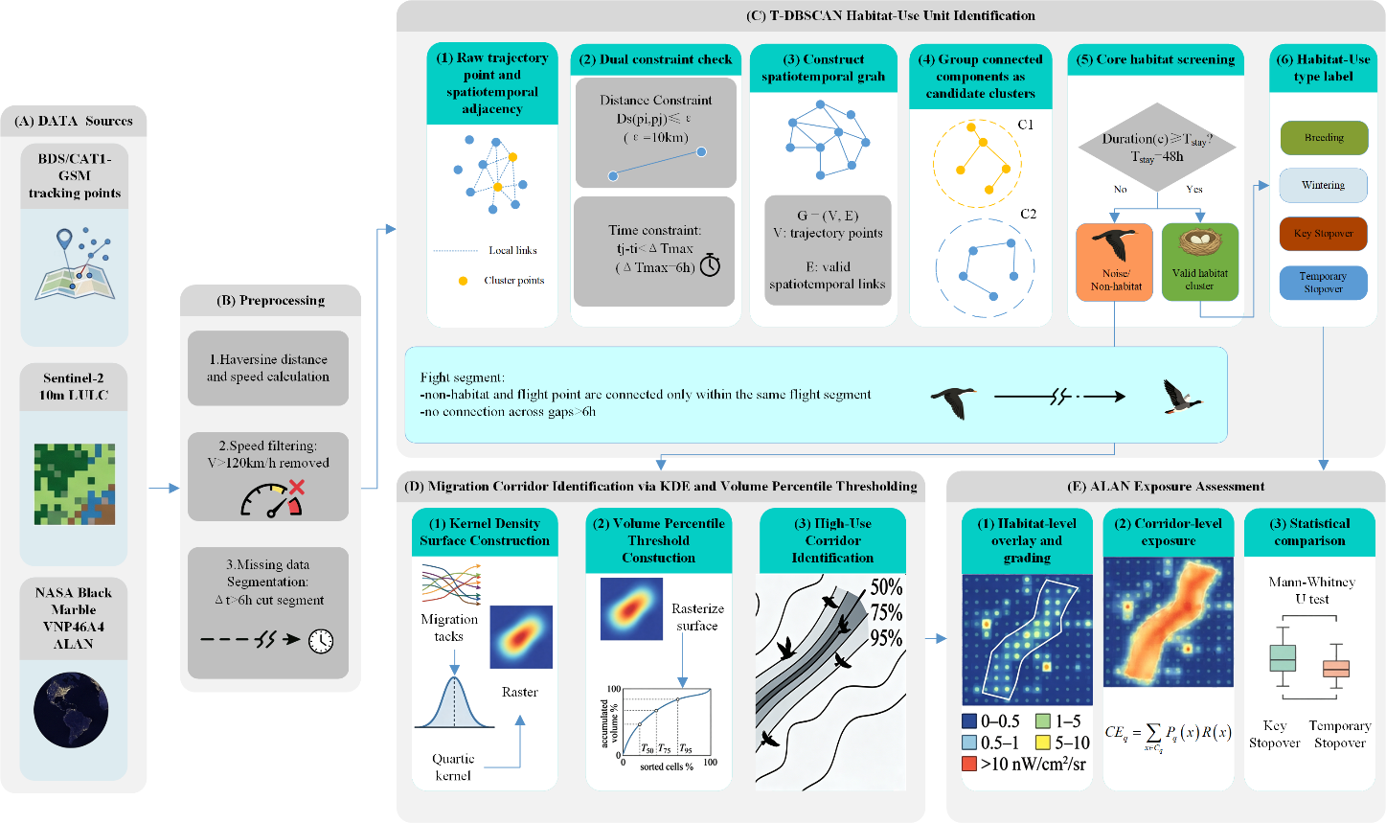
Fig.1. Methodological framework for identifying habitat-use units and high-use migration corridors and assessing ALAN exposure.

3.1 Trajectory Preprocessing
Trajectory preprocessing followed the basic principle in animal movement ecology of “quality control first, ecological interpretation second”(Demšar et al., 2021; Fischer, 2024; Gupte et al., 2022). The Haversine formula was used to calculate the great-circle distance between adjacent location points:
$$\begin{aligned}d_{ij}=2R×arcsin\left(sqrt\left(sin^{2}\left(\frac{φ_{j}-φ_{i}}{2}\right)+cosφ_{i}×cosφ_{j}×sin^{2}\left(\frac{λ_{j}-λ_{i}}{2}\right)\right)\right)\#（1）\end{aligned}$$
Where $d_{ij}$ is the great-circle distance between points i and j, $R$ is the Earth’s radius, $φ$ is latitude, and $λ$ is longitude. The instantaneous speed was then calculated from the time interval $Δt_{ij}$ between adjacent points:
$$\begin{aligned}v_{i}=\frac{d_{ij}}{∆t_{ij}}\#（2）\end{aligned}$$
To remove obvious anomalous location points while retaining potentially rapid wind-assisted migration segments, 120 km/h was set as the maximum reasonable speed threshold(Gupte et al., 2022). Point pairs exceeding this threshold were treated as anomalies and removed. This processing is consistent with current recommendations in animal trajectory preprocessing to define a speed upper limit based on species movement capacity(Gupte et al., 2022).
Because long gaps in observation can create false connections in subsequent clustering and corridor identification, the trajectory was divided into a new segment whenever the time gap between adjacent points exceeded 6 h. This threshold matches the approximately 1 h sampling interval used in this study, preserves small interruptions caused by short data gaps, and avoids forcing two independent behavioral phases into a single trajectory segment when missing data are prolonged.

3.2 Habitat-Use Unit Identification and Classification Based on T-DBSCAN
【Original English】
The study used a T-DBSCAN framework to identify habitat-use clusters of the tracked Common Crane, including breeding, wintering, temporary stopover and key stopover sites. Unlike traditional DBSCAN, which mainly relies on a minimum number of points (minPts), T-DBSCAN is better suited to animal tracks with nonuniform sampling intervals because it incorporates spatial proximity, temporal continuity, and minimum residence duration(He et al., 2025; K. Wang et al., 2023). Fig.1.C shows the workflow used in this study.
【Revised English】
The study used a temporal density-based spatial clustering (T-DBSCAN) framework to identify residence clusters of the tracked Common Crane. The implementation was tailored to a long-duration individual trajectory: cluster validity depended on spatial proximity, temporal continuity, and elapsed residence duration, rather than on pooling observations across individuals or relying on a point-count threshold alone.The workflow comprised five steps: (1) divide the trajectory at gaps longer than 6 h; (2) evaluate spatial and temporal connectivity among points within each segment; (3) construct a spatiotemporal connectivity graph; (4) extract connected components and retain only those meeting the minimum residence duration; and (5) classify retained components as breeding, wintering, key stopover, or temporary stopover units according to chronological position and duration.
【Original English】
For each pair of trajectory points within the same trajectory segment, $p_{i}$ and $p_{j}$ (where j > i), they were regarded as spatiotemporally connected when both Eq. (3) and Eq. (4) were satisfied:
$$\begin{aligned}D_{s}\left(p_{i},p_{j}\right)≤ε\#（3）\end{aligned}$$
and $\begin{matrix}\begin{aligned}t_{j}-t_{i}≤ΔT_{max}\#（4）\end{aligned}\end{matrix}$
【Original English】
Where $D_{s}\left(p_{i},p_{j}\right)$ denotes the spatial distance between two points, $ε$ is the spatial radius threshold, and $ΔT_{max}$ is the temporal continuity threshold. Based on this rule, a spatiotemporal connectivity graph of trajectory points was first constructed, and connected components were then extracted as candidate stop clusters. Each connected component in the graph was treated as a candidate habitat-use cluster, denoted $C$.
【Revised English】
where $D_{s}$is the spatial distance, $ε$ $i$s the spatial-radius threshold, and $ΔT_{max}$is the temporal-continuity threshold. When both constraints were satisfied, an edge $\left(p_{i} , p_{j}\right)$was added to the edge set $E$, thereby constructing the spatiotemporal connectivity graph. The connected components of this graph were treated as candidate residence clusters $C_{i}$, with each cluster consisting of points $p_{k}∈C_{i}$. Thus, cluster membership depended on a continuous chain of spatially and temporally neighboring observations rather than on point density alone.
$$\begin{aligned}E\left(p_{i},p_{j}\right)=\left\{\begin{aligned}1, &D_{s}\left(p_{i},p_{j}\right)≤ε and { t}_{j}-t_{i}≤ΔT_{max} \\ 0, &otherwise\end{aligned}\right.\#\left(5\right)\end{aligned}$$
【Original English】
The setting of the spatial radius $ε$ needed to balance ecological scale and clustering resolution. Previous studies on geese and large migratory waterbirds often used 30 km as a relatively relaxed scale for defining stopover sites(Nam et al., 2025; Shariatinajafabadi et al., 2014; Yi et al., 2022). However, because this study focused more on relatively compact habitat patches rather than broadly defined stopover regions, and also sought to avoid erroneously merging nearby stopover sites, $ε=10km$ was ultimately selected(He et al., 2025; Kölzsch et al., 2016). The temporal continuity threshold was set to $ΔT_{max}=6h$, consistent with the trajectory segmentation rule. This parameter combination yielded ecologically interpretable clusters in terms of the number of habitat-use units, spatial location, and land-cover consistency, and was therefore adopted in the main analysis.【Revised English】
The spatial radius $ε$ was set to 10 km. Previous studies of geese and other large migratory waterbirds have sometimes used scales of approximately 30 km to delineate broad stopover regions (Nam et al., 2025; Shariatinajafabadi et al., 2014; Yi et al., 2022). Because the present analysis targeted relatively compact habitat-use patches and sought to avoid merging nearby but distinct sites, a more conservative 10-km radius was adopted (He et al., 2025; Kölzsch et al., 2016). The temporal-continuity threshold was $ΔT_{max}$= 6 h, matching the missing-data segmentation rule and allowing short interruptions in an approximately hourly record without connecting observations across prolonged gaps. Table 2 reports each parameter, its ecological rationale, and its role in the workflow. 这里调整了段落顺序，原本在After clustering这段之前的
For any candidate cluster $C_{i}$, its duration was defined as:
$$\begin{aligned}Duration\left(C_{i}\right)=max\left(t_{k}\right)-min\left(t_{k}\right) \#\left(6\right)\end{aligned}$$
【Original English】
where $p_{k}∈C_{i}$denotes a trajectory point $p_{k}$belonging to candidate cluster $C_{i}$, and $t_{k}$is the timestamp of that trajectory point. When $Duration\left(C\right)≥T_{stay}$, the cluster was retained as a valid habitat-use cluster; otherwise, it was treated as non-habitat noise. Referring to the commonly used criterion of staying longer than 48 h in studies of large migratory waterbirds, and in conjunction with recent applications of T-DBSCAN to stopover identification in migratory birds, we set $T_{stay}$ was set to 48 h (He et al., 2025; Kölzsch et al., 2016; Shariatinajafabadi et al., 2014).
【Revised English】
where $t_{k}$denotes the timestamp of any point $p_{k}$within cluster $C_{i}$, and $max⁡(t_{k})$and $min⁡(t_{k})$denote the latest and earliest timestamps in the cluster, respectively. A candidate component was retained as a valid habitat-use cluster when its $Duration\left(C_{i}\right)$was at least 48 h; otherwise, it was treated as non-habitat noise. Using elapsed residence time rather than a minimum point count reduces sensitivity to short-term changes in sampling frequency. The 48-h criterion is consistent with stopover definitions used for large migratory waterbirds and with recent applications of T-DBSCAN to bird-tracking data (He et al., 2025; Kölzsch et al., 2016; Shariatinajafabadi et al., 2014).
【Original English】
After clustering, valid clusters were further classified as breeding site, wintering site, key stopover site, or temporary stopover site according to residence duration, seasonal occurrence, and position along the migration route. Clusters occurring after spring migration were classified as breeding sites only when the residence duration was ≥30 days, whereas clusters occurring after autumn migration were classified as wintering sites only when the residence duration was ≥30 days. This threshold was used to distinguish seasonal residence areas from migration stopovers. Similar crane-tracking studies have defined breeding and wintering sites as locations where cranes stayed for more than 30 days after spring and autumn migration, respectively(Nam et al., 2025). For clusters occurring during migration, sites with a residence duration of ≥14 days were classified as key stopover sites, while valid clusters that met the 48h minimum residence criterion but lasted <14 days were classified as temporary stopover sites. The 14-day threshold was used to distinguish prolonged staging or refuelling nodes from short resting sites, consistent with previous tracking studies that identified critical staging or stopover sites using a >14-day residence criterion(D. Li et al., 2024; Yi et al., 2022). Finally, the minimum geometric boundary (convex hull) was then used as a simple geometric approximation of each habitat-use cluster for subsequent land-cover interpretation and overlay analysis of ALAN exposure.
【Added English】
Classification was validated as an ecological plausibility check after, rather than during, clustering. Each cluster polygon was overlaid on the independent Sentinel-2 10-m land-use/land-cover layer and inspected for correspondence with ecologically interpretable backgrounds such as water, flooded vegetation, cropland-wetland mosaics, forest, or grassland. Because land cover was not used to construct or label the clusters, this comparison provides an independent consistency check.
Table 2. Key parameter settings and their basis.
【Original English】
Parameter | Value | Basis for setting | Reference or note
Maximum speed threshold | 120 km/h | Removes obvious anomalous location points while retaining rapid wind-assisted migration segments | Gupte et al., 2022
Missing-data segmentation threshold | 6 h | Avoids false connections caused by long data gaps and maintains consistency with clustering and corridor construction | This study; set according to the data frequency
T-DBSCAN spatial radius ($ε$) | 10 km | Balances compact habitat-use unit identification and avoidance of erroneous merging of nearby stopover  sites, while remaining compatible with scales used in studies of medium- and large-bodied migratory waterbirds | He et al., 2025; Kölzsch et al., 2016
T-DBSCAN temporal continuity ($ΔT_{max}$) | 6 h | Maintains local temporal continuity while reflecting the missing-data structure | This study
Minimum residence duration ($T_{stay}$) | 48 h | Consistent with commonly used thresholds in migratory waterbird stopover studies and recent bird applications of T-DBSCAN | He et al., 2025; Kölzsch et al., 2016; Shariatinajafabadi et al., 2014
Nighttime-light radiance classification scheme | 0-0.5; 0.5-1; 1-5; 5-10; >10 nW/cm$​^{2}$/sr | Preserves the low-value transition characteristics of Black Marble and distinguishes low, medium, and high levels of anthropogenic ALAN exposure | Dominoni et al., 2013; Horton et al., 2023; Raap et al., 2015; Z. Wang et al., 2022
Habitat-use-unit classification thresholds | Breeding and wintering sites: ≥30 days; key stopover sites: ≥14 days; temporary stopover sites: ≥48 h and <14 days | Distinguishes seasonal residence areas from migration stopovers and separates prolonged staging or refueling nodes from short-term resting sites | D. Li et al., 2024; Nam et al., 2025; Yi et al., 2022
【Revised English】
Parameter | Value | Basis for setting | Reference or note
Maximum speed threshold | 120 km/h | Removes obvious anomalous location points while retaining rapid wind-assisted migration segments | Gupte et al., 2022
Missing-data segmentation threshold | 6 h | Avoids false connections caused by long data gaps and maintains consistency with clustering and corridor construction | This study; set according to the data frequency
T-DBSCAN spatial radius (epsilon_s) | 10 km | Balances compact habitat-use unit identification and avoidance of erroneous merging of nearby stopover sites, while remaining compatible with scales used in studies of medium- and large-bodied migratory waterbirds | He et al., 2025; Kölzsch et al., 2016
T-DBSCAN temporal continuity (epsilon_t) | 6 h | Maintains local temporal continuity while reflecting the missing-data structure | This study
Minimum residence duration | 48 h | Consistent with commonly used thresholds in migratory waterbird stopover studies and recent bird applications of T-DBSCAN | He et al., 2025; Kölzsch et al., 2016; Shariatinajafabadi et al., 2014
Nighttime-light radiance classification scheme | 0-0.5; 0.5-1; 1-5; 5-10; >10 nW cm⁻² sr⁻¹ | Preserves the low-value transition characteristics of Black Marble and distinguishes low, medium, and high levels of anthropogenic ALAN exposure | Dominoni et al., 2013; Horton et al., 2023; Raap et al., 2015; Z. Wang et al., 2022
Habitat-use-unit classification thresholds | Breeding and wintering sites: ≥30 days; key stopover sites: ≥14 days; temporary stopover sites: ≥48 h and <14 days | Distinguishes seasonal residence areas from migration stopovers and separates prolonged staging or refueling nodes from short-term resting sites | D. Li et al., 2024; Nam et al., 2025; Yi et al., 2022
Post-classification validation | Sentinel-2 land-cover plausibility and trajectory-geometry checks | Assesses ecological interpretability without using land cover to fit the clusters | Internal validation; not field ground truth or population validation
Habitat-exposure sensitivity | Class boundaries ±20%; concave, linear, and convex ordinal scores | Tests whether metric rankings and priority-unit identification depend on one operational classification or equal-interval score vector | This study; fixed polygons, raster alignment, and area calculations
Corridor CEq annual sensitivity | 2022, 2023, and 2024 VNP46A4 composites | Tests dependence of the 50%-75%-95% corridor gradient on the selected annual radiance background | This study; fixed corridors and migration-intensity weights

3.3 Identification of High-Use Corridors Based on the Migration-Intensity Surface
After habitat-use units were identified, all non-habitat points were treated as trajectory points in a flight state and connected in temporal order within the same segment to form flight lines. Adjacent non-habitat points were connected only within the same trajectory segment, and no connection was made across gaps longer than 6 h. Let the sequence of flight trajectory points be $p=p_{1},p_{2},…,p_{n}$; connecting adjacent points yielded the set of flight segments $L=L_{1},L_{2},…,L_{m}$. These flight segments were then used to construct a migration-intensity surface and to extract high-use corridors (Fig.1.D).
Kernel density estimation employed a quartic kernel to construct a smooth surface, with the basic form:
$$\begin{aligned}K\left(u\right)=\left\{\begin{matrix}\frac{3}{π}(1-u^{2})^{2}, & 0≤u<1 \\ 0, & u≥1\end{matrix}\right.\#\left(7\right)\end{aligned}$$
where $u$ denotes the dimensionless distance argument of the kernel function. The kernel weight decreases as $u$ increases, and the contribution becomes zero when u reaches or exceeds 1.
Migration intensity D(x) was then estimated by applying the quartic kernel along all flight segments:
$$\begin{aligned}D\left(x\right)=\sum_{j=1}^{m}{w_{j}\int_{L_{j}}{\frac{1}{h^{2}}K\left(u\right)}} ds,u=\frac{\left|x-s\right|}{h}\#\left(8\right)\end{aligned}$$
where $x$ is the location of the raster cell center at which migration intensity is estimated, $s$denotes a position along the flight segment $L_{j}$, $h$ is the search radius or bandwidth, which was set to 10,000 m, in this study; $L_{j}$ is the $j$-th flight segment, $w_{j}$ is the segment weight set to 1 in this study, $K\left(u\right)$is the quartic kernel function, and $ds$ denotes the line-integration element along the flight segment. The term $u=\frac{\left|x-s\right|}{h}$ therefore represents the normalized distance between the raster cell center and a position on the flight segment.
After obtaining the migration-intensity raster, nested high-use corridors were further extracted using a volume percentile threshold method. For the $i$-th raster cell, its volume contribution was defined as $V_{i}=D_{i}×A_{i}$, where $D_{i}$ is the migration intensity of the cell and $A_{i}$ is the cell area; the total migration volume over the full domain was $V_{total}=Σ_{i}V_{i}$. For a target percentile $p$, the corresponding target volume was $V_{p}=\frac{p}{100}×V_{total}$. All cells were sorted from high to low by $D_{i}$, and cumulative volume was calculated. The density value at which the cumulative volume reached or exceeded $V_{p}$ was taken as the threshold $T_{p}$, and the corridor region was then defined as${\text{Ω}}_{P}=\left\{x | D\left(x\right)≥T_{p}\right\}$.
In this study, 50%, 75%, and 95% corridors were extracted. The 50% corridor represents the core corridor with the most concentrated tracked migratory activity and the highest degree of repeated use; the 75% corridor represents the main migration range; and the 95% corridor represents the broader corridor covering almost all migratory activity. This nested representation can simultaneously depict both the core and peripheral zones of migration paths and is therefore suitable for subsequent graded comparisons of ALAN exposure.

3.4 Assessment of ALAN Exposure in Habitat-Use Units and Corridors
【Original English】
Habitat-level ALAN exposure was obtained by overlaying habitat-use unit polygons with the VNP46A4 radiance raster. To capture both exposure extent and exposure level, nighttime-light radiance was divided into five classes: $S_{1}=0-0.5,S_{2}=0.5-1,S_{3}=1-5,S_{4}=5-10,andS_{5}>10nW/cm​2/sr$. Because the Black Marble annual composite product sets residual background radiance below 0.5nW/cm$​^{2}$/sr to zero during processing(Huang et al., 2023; Román et al., 2018), the 0-0.5 class was defined as near-background environment or very low-light environment. The remaining four classes represent potential influence, low exposure, moderate exposure, and high exposure, respectively. These classes are remote-sensing exposure categories rather than Common Crane-specific physiological thresholds. The purpose of using this classification is to preserve the product’s low-value transition characteristics and to distinguish anthropogenic ALAN environments of different intensities at the landscape scale(Burt et al., 2023; Dominoni et al., 2013; Horton et al., 2023; McLaren et al., 2018; Raap et al., 2015).
【Revised English】
Habitat-level ALAN exposure was quantified by overlaying each habitat-use polygon with the 2023 VNP46A4 radiance raster and summing the mapped area in five non-overlapping classes: [0, 0.5), [0.5, 1), [1, 5), [5, 10), and [10, ∞) nW cm⁻² sr⁻¹. The first class represents the near-background category, and the remaining classes represent progressively brighter operational exposure categories. These classes are remote-sensing categories rather than Common Crane-specific physiological thresholds.
【Original English】
Let A denote the total area of an individual habitat-use unit, and $S_{1},S_{2},S_{3},S_{4},S_{5}$ the areas corresponding to the five nighttime-light classes; assigning scores $w_{1},w_{2},w_{3},w_{4},w_{5}$ of 0, 1, 2, 3, and 4 respectively, the habitat nighttime-light pollution index (HNLPI) is:
【Revised English】
Let A = S1 + S2 + S3 + S4 + S5 be the total classified area of a habitat-use unit, and let S1–S5 denote the areas in the five radiance classes. The original HNLPI assigns the ordinal class scores w = (0, 1, 2, 3, 4); division by 4 in STDHNLPI is equivalent to using the normalized score vector c = (0, 0.25, 0.50, 0.75, 1.00). These scores provide an operational ordinal scale and are not species-specific biological response coefficients. The habitat nighttime-light pollution index (HNLPI) is the area-weighted mean class score:
$$\begin{aligned}HNLPI=\sum_{i=1}^{5}{w_{i}×\frac{S_{i}}{A}}\#\left(9\right)\end{aligned}$$
The standardized habitat nighttime-light pollution index ($STDHNLPI$) is then defined as:
$$\begin{aligned}STDHNLPI=\frac{HNLPI}{4}\#\left(10\right)\end{aligned}$$
【Original English】
STDHNLPI ranges from 0 to 1 and can be directly used to compare overall ALAN exposure levels among habitats-use units of different sizes. To characterize exposure extent and the proportion of high-level exposure, the pollution coverage rate and high-exposure ratio were defined as:
【Revised English】
STDHNLPI ranges from 0 to 1 and represents overall area-weighted ALAN exposure. The pollution coverage rate (PCR; Eq. 11) is the proportion of the habitat-use unit assigned to classes S2–S5, whereas the high-exposure ratio (HER; Eq. 12) is the proportion assigned to S4 and S5 (radiance ≥5 nW cm⁻² sr⁻¹). PCR therefore describes exposure extent, and HER describes the prevalence of the two brightest operational classes.
$$\begin{aligned}PCR=\frac{S_{2}+S_{3}+S_{4}+S_{5}}{A}\#\left(11\right)\end{aligned}$$
$$\begin{aligned}HER=\frac{S_{4}+S_{5}}{A}\#\left(12\right)\end{aligned}$$
【Original English】
Because habitat-use units may exhibit either “large-area low light” or “small-area high light” coverage, an exposure level score (ELS) was constructed within the area under effective ALAN coverage:
【Revised English】
Because the same STDHNLPI value can arise from broad low-intensity coverage or spatially restricted brighter coverage, ELS was calculated as the average normalized class score within the ALAN-covered portion of the polygon:
$$\begin{aligned}ELS=\frac{1S_{2}+2S_{3}+3S_{4}+4S_{5}}{4A_{lit}}\#\left(13\right)\end{aligned}$$
【Original English】
Where $A_{lit}=S_{2}+S_{3}+S_{4}+S_{5}$ is the total area with valid nighttime-light radiance classification. ELS reflects the average exposure intensity within the portion of the habitat-use unit that is already covered by ALAN.
【Revised English】
where A_lit = S2 + S3 + S4 + S5 is the ALAN-covered area. For A_lit > 0, ELS ranges from 0 to 1 and represents conditional exposure intensity within the covered portion. Consequently, STDHNLPI = PCR × ELS. When A_lit = 0, ELS is undefined and the unit was excluded from ELS inferential analyses; for visualization in Fig. 6 only, such units were displayed at ELS = 0.
【Revised English】
To compare ALAN exposure among corridor levels, each corridor Cq (q = 50%, 75%, or 95%) was overlaid with the migration-intensity and nighttime-light rasters. For pixel x within Cq, Dx denotes migration intensity, ax denotes pixel area, and Rx denotes nighttime-light radiance. Migration-use weights were normalized separately within each corridor:
$$\begin{aligned}P_{q}\left(x\right)=\frac{D(x)a_{x}}{\sum_{x∈C_{q}}{D(x)}a_{x}},x∈C_{q}\#\left(14\right)\end{aligned}$$
where the normalized weights sum to 1 within Cq. Expected corridor ALAN exposure was then calculated as:
$$\begin{aligned}CE_{q}=\sum_{x∈C_{q}}{P_{q}}\left(x\right)R\left(x\right)\#\left(15\right)\end{aligned}$$
【Revised English】
CEq represents the expected nighttime-light radiance encountered within a corridor under the corridor-specific migration-use probability distribution. It retains the radiance unit nW cm⁻² sr⁻¹ and is an exposure index, not a physiological dose or direct estimate of ecological risk. Because weights are normalized within each corridor, differences among CEq values reflect the spatial overlap between repeated route use and brighter or darker cells rather than total corridor area alone.

3.5 Statistical Analysis
【Original English】
Descriptive statistics were used to summarize ALAN exposure characteristics among habitat-use types and corridor levels. Because only one breeding site and one wintering site were identified, inferential statistical comparisons among habitat-use types were conducted mainly between key stopover sites and temporary stopover sites. Mann-Whitney U tests were used to compare PCR, STDHNLPI, ELS, mean radiance, P90, and HER. Continuous nighttime-light radiance statistics, including the mean, median, and the 75th, 90th, and 95th percentiles of radiance values (P75, P90, and P95), were used as supplementary information to interpret local strong light or overall background brightness, whereas STDHNLPI, PCR, HER, and ELS constituted the core exposure assessment system in this study.
【Revised English】
Descriptive statistics summarized ALAN exposure by habitat-use type and corridor level. Because only one breeding unit and one wintering unit were identified, inferential comparisons focused on the six key and ten temporary stopover units. Baseline differences in PCR, STDHNLPI, ELS, and HER were evaluated using exact label-permutation Mann–Whitney U tests because sample sizes were small and tied values were common. Rank-biserial correlation was reported as the effect size, and the four baseline p values were adjusted using the Benjamini–Hochberg procedure. ELS comparisons included only units with A_lit > 0; continuous mean and percentile radiance statistics were retained as descriptive context.
Habitat-metric sensitivity was evaluated while holding the 18 habitat-use polygons, raster alignment, and calculation formulas constant. The baseline radiance boundaries of 0.5, 1, 5, and 10 nW cm⁻² sr⁻¹ were compared with boundaries decreased by 20% (0.4, 0.8, 4, and 8) and increased by 20% (0.6, 1.2, 6, and 12). Sensitivity to the spacing of ordinal class scores was evaluated using u = (0, 0.25, 0.50, 0.75, 1.00) and the concave, linear, and convex functions u^0.5, u, and u^2, respectively. The same score vector was used for STDHNLPI and ELS. Robustness relative to the baseline threshold and linear score scheme was assessed using Spearman rank correlation, overlap among the five highest-STDHNLPI units, and maximum rank shift. Exact key-versus-temporary comparisons were repeated across the nine threshold-by-score scenarios.
Corridor CEq sensitivity was evaluated by recalculating the index with the 2022, 2023, and 2024 VNP46A4 annual composites while holding migration-intensity weights, corridor boundaries, raster-processing settings, and the CEq formula constant. Annual robustness was summarized using corridor-specific coefficients of variation, normalized 75%/50% and 95%/50% exposure ratios, and consistency of the 50% > 75% > 95% ordering. Because the three corridors are nested and only three annual composites were available, emphasis was placed on effect magnitude and ordering rather than null-hypothesis significance tests. Detailed outputs and internal consistency checks are provided in Supplementary Tables S1–S6 and Figs. S1–S4. Drafting of the sensitivity-analysis scripts was assisted by ChatGPT (OpenAI); the authors independently reviewed the code, reran all analyses from the supplied data, and verified the numerical outputs.

4 Results

4.1 Habitat-use unit classification and type-specific differences in ALAN exposure
T-DBSCAN-based spatiotemporal clustering identified 18 habitat-use units, including one breeding site, one wintering site, six key stopover sites, and ten temporary stopover sites (Fig.2). These habitat-use units formed a clear network structure along the tracked migration route: the southern part corresponded to the wintering region, the central part comprised multiple stopover nodes, and the northern part represented the breeding region. The clustering results were generally consistent with the geometric form of the original trajectory, indicating that the dual spatiotemporal constraints effectively separated residence clusters from movement segments.
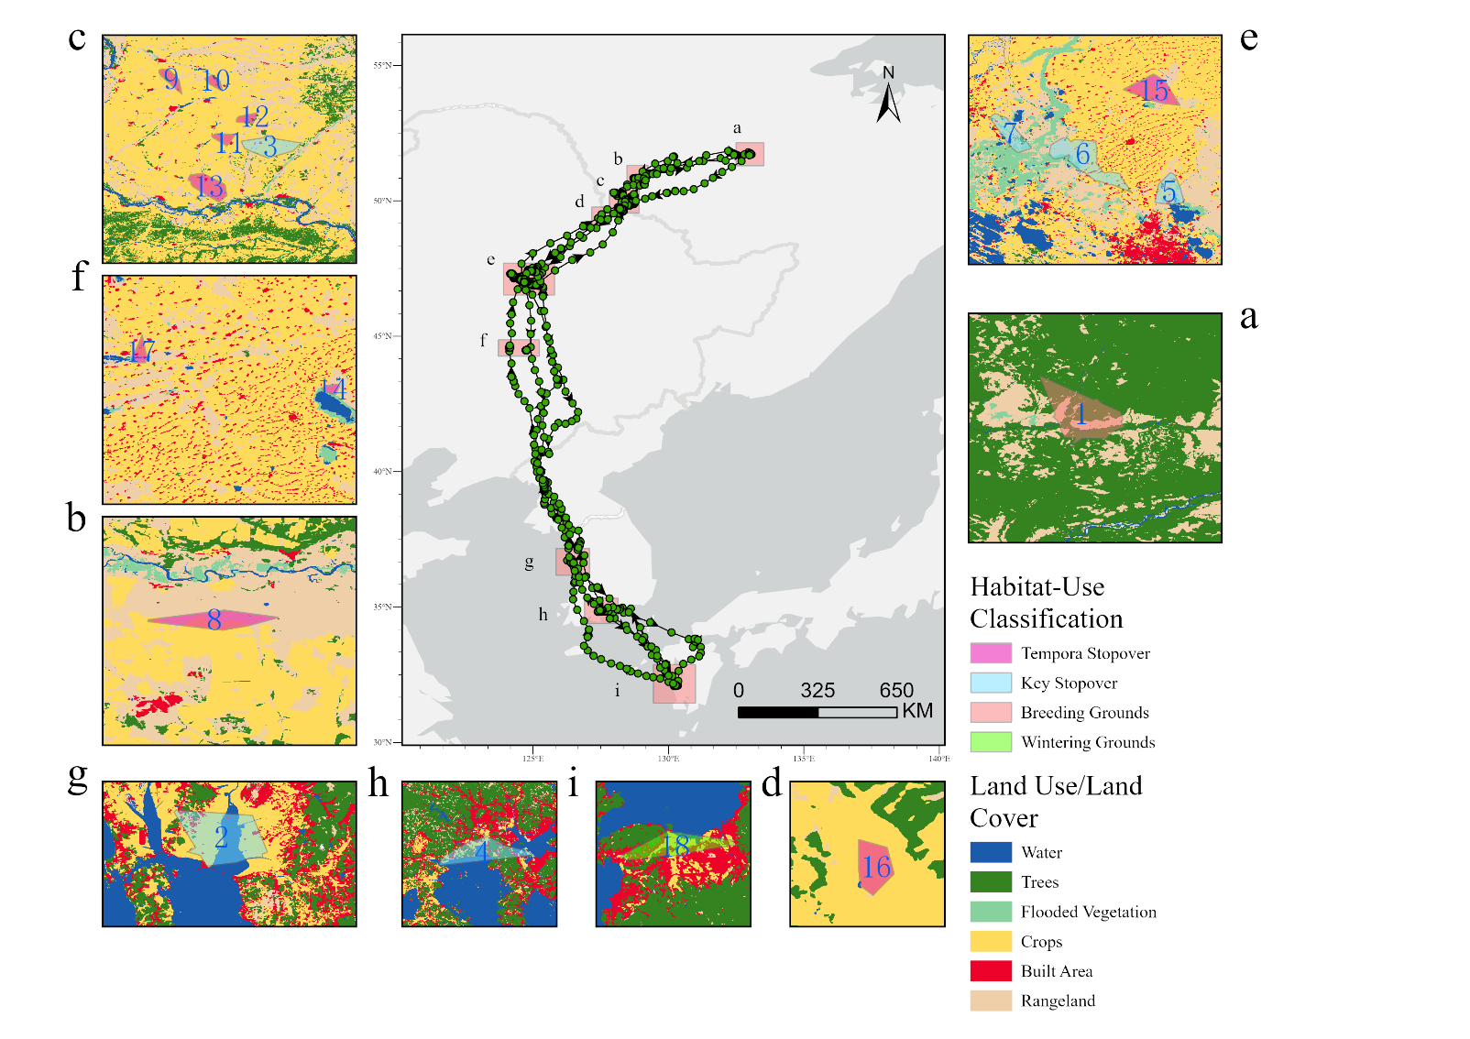
Fig.2. Migration trajectory, habitat-use classification, and land-cover background of representative habitat-use units.
【Original English】
The land-cover background further supported the ecological plausibility of habitat-use unit identification. The breeding (Fig.2.a) and wintering sites (Fig.2.i) were mainly located in landscapes characterized by mosaics of water bodies, flooded vegetation, and cropland-wetland landscapes; several key stopover sites occurred in areas where rivers, lakes, wetlands, and cropland were intermingled; and some temporary stopover sites were embedded in cropland or grassland landscapes. Although land cover was not used in the clustering classification itself, the clustering results were broadly consistent with ecologically interpretable land-surface types, indicating that the identified habitat-use units were ecologically interpretable.
【Revised English】
The post-classification land-cover comparison supported the ecological plausibility of the identified units (Fig. 2). The breeding and wintering polygons occurred mainly in mosaics containing water, flooded vegetation, and cropland-wetland landscapes; several key stopover sites occurred where rivers, lakes, wetlands, and cropland were intermingled; and some temporary stopovers were embedded in cropland or grassland. The clustering algorithm did not use these land-cover classes, so their correspondence with plausible crane habitat provides an independent consistency check.
Differences in ALAN exposure among habitat-use types were evident (Table 3). Mean PCR and STDHNLPI were 0.3822 and 0.1432 for key stopovers, compared with 0.0294 and 0.0084 for temporary stopovers. Among units with detectable ALAN coverage, mean conditional ELS was 0.3109 for key stopovers and 0.2803 for temporary stopovers; ELS was undefined for the breeding unit. The wintering unit showed relatively high coverage and overall exposure (PCR = 0.5950; STDHNLPI = 0.2004; ELS = 0.3368). Exact permutation tests indicated greater PCR at key than temporary stopovers (U = 52.0, p = 0.0141, rank-biserial correlation = 0.733) and greater STDHNLPI (U = 51.0, p = 0.0207, rank-biserial correlation = 0.700); both remained significant after Benjamini–Hochberg adjustment (q = 0.0415). Conditional ELS (U = 19.5, p = 0.4459) and HER (U = 32.5, p = 0.7500) showed no clear group differences.
Table 3. Mean ALAN exposure indicators for different habitat-use types. ELS means include only habitat-use units with detectable ALAN coverage.
Habitat-use type | Number | Mean area (km²) | Mean radiance | Mean P90 | Mean PCR | Mean STDHNLPI | Mean ELS | Mean HER
Breeding site | 1 | 44.4997 | 0.0000 | 0.0000 | 0.0000 | 0.0000 | NA | 0.0000
Key stopover site | 6 | 155.0446 | 0.5787 | 1.0367 | 0.3822 | 0.1432 | 0.3109 | 0.0143
Temporary stopover site | 10 | 53.7477 | 0.0254 | 0.0520 | 0.0294 | 0.0084 | 0.2803 | 0.0008
Wintering site | 1 | 30.0808 | 0.7117 | 2.1035 | 0.5950 | 0.2004 | 0.3368 | 0.0083
At the individual habitat-use unit level, ALAN exposure was highly heterogeneous (Table 4). Key stopover site 4 showed complete ALAN coverage (PCR = 1.0000) and had the highest STDHNLPI value (0.5101) and ELS value (0.5101), making it the most strongly exposed habitat-use unit among all sites. Key stopover site 2 likewise showed full ALAN coverage, but its internal exposure intensity was lower than that of site 4 (STDHNLPI = 0.2728, ELS = 0.2728). The wintering site ranked third among all habitat-use units in terms of STDHNLPI. By contrast, most temporary stopover sites showed low coverage and low intensity, indicating relatively dark nighttime environments.
Table 4. Top five high-exposure habitat-use units ranked by the standardized nighttime-light pollution index (STDHNLPI).
Habitat-use unit ID | Habitat-Use type | Mean radiance | P90 | PCR | STDHNLPI | ELS | HER
4 | Key stopover site | 2.5705 | 4.7271 | 1.0000 | 0.5101 | 0.5101 | 0.0858
2 | Key stopover site | 0.7187 | 0.9675 | 1.0000 | 0.2728 | 0.2728 | 0.0000
18 | Wintering site | 0.7117 | 2.1035 | 0.5950 | 0.2004 | 0.3368 | 0.0083
17 | Temporary stopover site | 0.0889 | 0.5204 | 0.1494 | 0.0374 | 0.2500 | 0.0000
13 | Temporary stopover site | 0.1314 | 0.0000 | 0.0905 | 0.0331 | 0.3657 | 0.0084

4.2 Nested high-use corridors and gradients in probability-weighted ALAN exposure
Kernel density estimation converted the flight segments into a continuous migration-intensity surface, showing that the tracked migratory activity was concentrated along a north–south pathway rather than being evenly distributed across the study area (Fig. 3). Areas of higher migration intensity were mainly located in the southern part of the route, the corridor across northeastern China, and route sections near the breeding area, suggesting potential movement bottlenecks. Based on this intensity surface, the volume percentile method further extracted nested 50%, 75%, and 95% high-use corridors, representing the core, main, and overall migration corridors, respectively.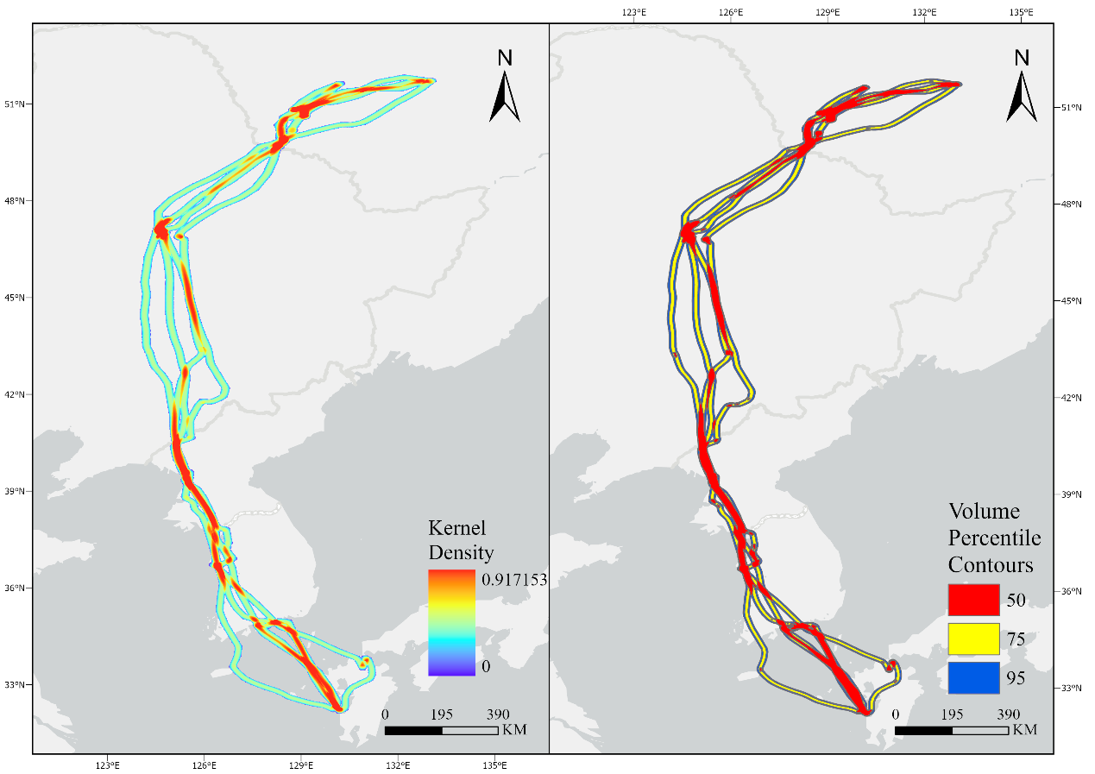
Fig.3. Kernel-density migration-intensity surface and nested 50%, 75%, and 95% high-use corridors.
The area differences among the three corridor levels were relatively limited (Table 5). The 50% core corridor covered 51,594.50 km², the 75% corridor covered 53,145.75 km², and the 95% corridor covered 53,450.25 km². Relative to the 50% corridor, the area of the 75% and 95% corridors increased by only 3.01% and 3.60%, respectively. This indicates that a substantial proportion of the tracked migratory activity was concentrated within a relatively compact spatial range rather than being widely dispersed spatially.
【Original English】
Compared with area changes, corridor-level ALAN exposure showed a clearer gradient. The probability-weighted expected ALAN exposure index ($CE_{q}$) was highest in the 50% core corridor (1.1667), and decreased to 1.0171 and 0.9840 in the 75% and 95% corridors, respectively. Relative to the 50% corridor, expected ALAN exposure decreased by 12.82% in the 75% corridor and by 15.66% in the 95% corridor. This pattern indicates that the most repeatedly used core corridor overlapped with relatively brighter nocturnal environments, whereas the broader peripheral corridor zones included comparatively darker areas.
【Revised English】
Compared with the small area changes, probability-weighted corridor exposure showed a clearer gradient. Expected radiance CE_q was highest in the 50% core corridor (1.1667 nW cm⁻² sr⁻¹) and decreased to 1.0171 and 0.9840 nW cm⁻² sr⁻¹ in the 75% and 95% corridors. Relative to the core corridor, area increased by only 3.01% and 3.60%, whereas expected exposure decreased by 12.82% and 15.66%. Thus, the exposure gradient cannot be explained by corridor area alone; it reflects stronger spatial overlap between repeated route use and brighter cells in the core corridor. But,this is an exposure pattern, not evidence that the bird selected the route because of ALAN.
Table 5. Area and ALAN exposure indicators of nested migration corridors.
【Original English】
Corridor level | Area (km²) | $$CE_{q}$$ | Relative area change (%) | Relative exposure change (%)
50% | 51594.5000 | 1.1667 | 0.0000 | 0.0000
75% | 53145.7500 | 1.0171 | 3.0100 | -12.8200
95% | 53450.2500 | 0.9840 | 3.6000 | -15.6600
【Revised English】
Corridor level | Area (km²) | Expected ALAN exposure, CEq (nW cm⁻² sr⁻¹) | Relative area change (%) | Relative exposure change (%)
50% | 51594.5000 | 1.1667 | 0.0000 | 0.0000
75% | 53145.7500 | 1.0171 | 3.0100 | -12.8200
95% | 53450.2500 | 0.9840 | 3.6000 | -15.6600

4.3 Patterns of ALAN Exposure in Habitat-Use Units and Corridors
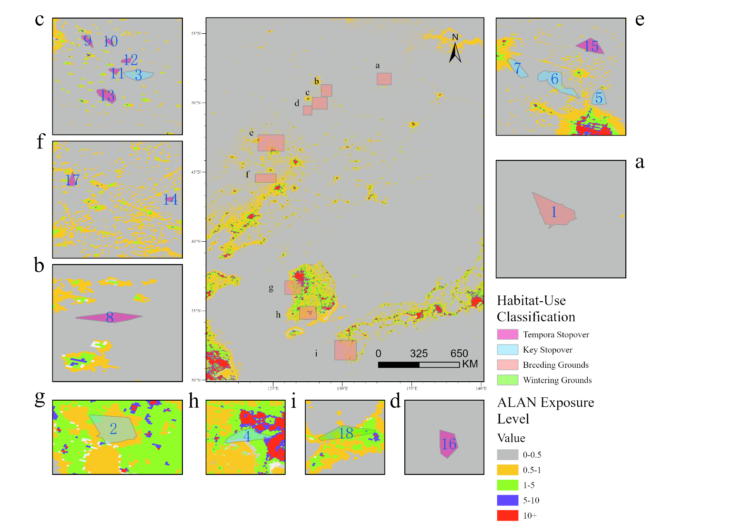
Fig.4. Classification of habitat-use unit ALAN exposure along the migration route.
【Original English】
The habitat-scale nighttime-light radiance classification map (Fig.4) and the area proportion chart of nighttime-light classes (Fig.5) jointly reveal differences among habitat-use units in both exposure extent and exposure structure. The breeding site (Fig.4.a) falls entirely within the near-background class of 0-0.5 nW/cm$​^{2}$/sr, indicating that its annual nighttime environment is extremely dark. The wintering site (Fig.4.i) and some key stopover sites include relatively large proportions of the 0.5-1 and 1-5 classes, whereas the most highly exposed key stopover sites also contain some 5-10 and >10 class areas. This also explains why HER values are generally not high for most habitat-use units, whereas PCR and STDHNLPI can still be relatively high: although many sites are affected by ALAN over a broad extent, exposure is concentrated mainly within the low- to moderate-intensity range.
【Revised English】
The habitat-scale nighttime-light radiance classification map (Fig. 4) and the area-proportion chart of nighttime-light classes (Fig. 5) jointly reveal differences among habitat-use units in both exposure extent and exposure structure. The breeding site (Fig. 4a) falls entirely within the near-background class of 0-0.5 nW cm⁻² sr⁻¹, indicating that its annual nighttime environment is extremely dark. The wintering site (Fig. 4i) and some key stopover sites include relatively large proportions of the 0.5-1 and 1-5 classes, whereas the most highly exposed key stopover sites also contain some 5-10 and >10 class areas. This pattern explains why HER values are generally low even where PCR and STDHNLPI are relatively high: although many sites are affected by ALAN over a broad extent, exposure is concentrated mainly within the low- to moderate-intensity range.
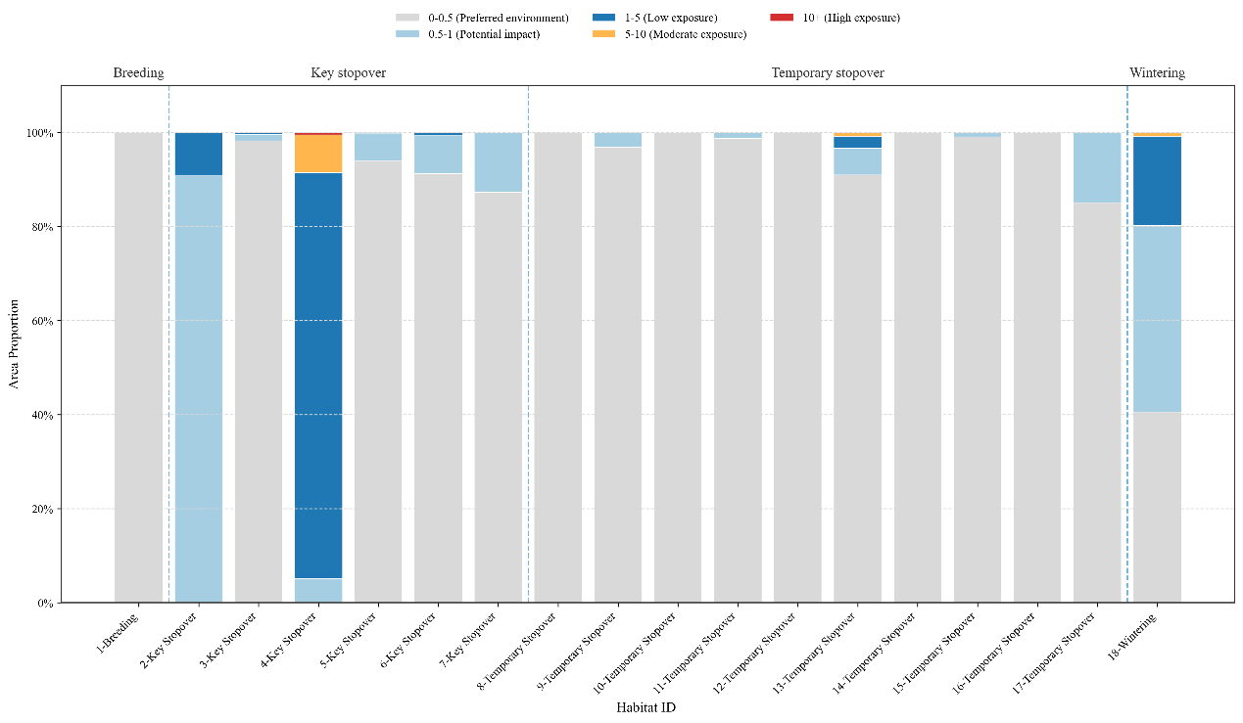
Fig.5. Area composition proportions of nighttime-light classes for each habitat-use unit.
The two-dimensional PCR–ELS plot (Fig. 6) separates exposure extent from conditional intensity. Units with no detectable ALAN coverage were displayed at the origin for visualization only and were excluded from ELS inferential comparisons. Several key stopovers, especially unit 4, combined broad coverage with relatively high conditional intensity, whereas most temporary stopovers had low PCR. Among ALAN-covered units, however, ELS values overlapped substantially between key and temporary stopovers. Temporary stopover unit 17 illustrates a low-coverage but moderate-intensity structure.
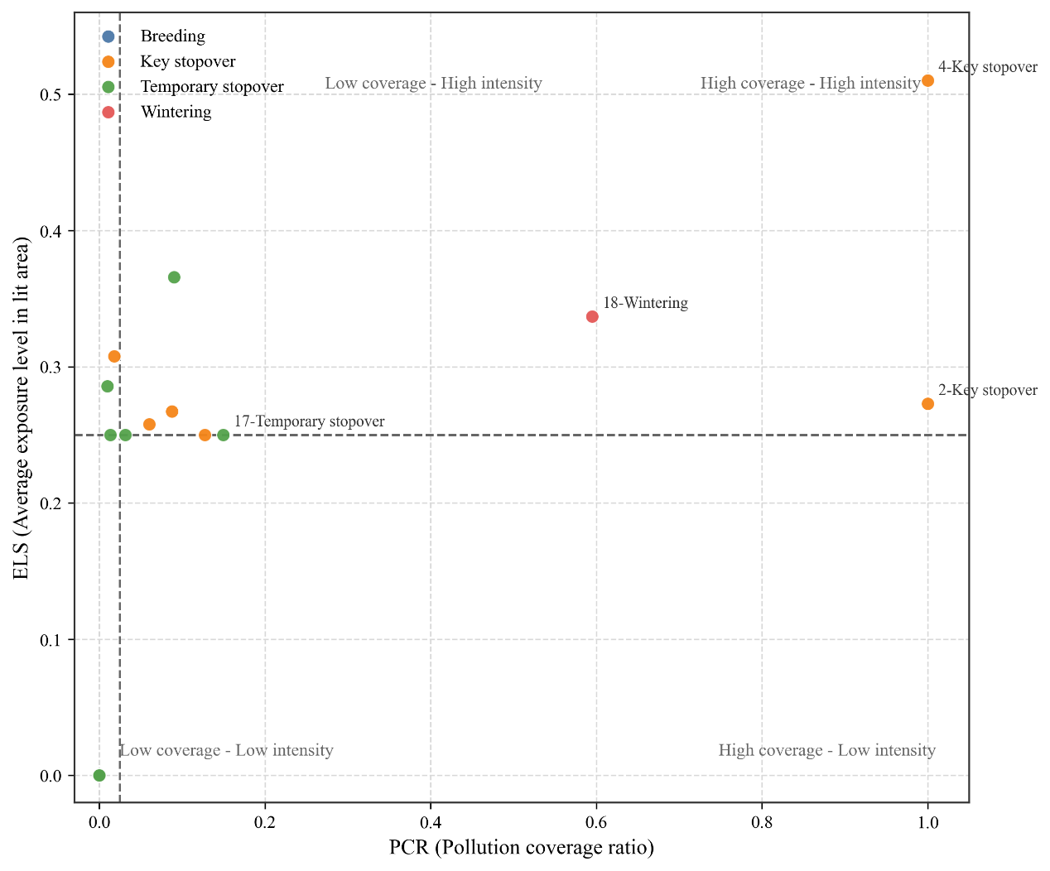
Fig.6. Relationship between habitat pollution coverage rate (PCR) and exposure level score (ELS). Units without detectable ALAN coverage are displayed at ELS = 0 for visualization only.
Overall, the results in Fig. 4–7 indicate a scale-dependent structure of ALAN exposure along the tracked migration route. At the habitat-use-unit scale, the combined indicators distinguish whether ALAN exposure is expressed as broad low-intensity coverage or as localized higher-intensity exposure. At the corridor scale, Fig. 7 further shows that corridor ALAN exposure is determined less by corridor area alone than by the spatial overlap between migration intensity and nighttime brightness. Although the 50%, 75%, and 95% corridors occupy similar spatial extents, the expected exposure index decreases from the core corridor to the broader corridors, suggesting that the added peripheral cells mainly represent lower-use and relatively darker route margins. Therefore, the 50% core corridor should not be interpreted simply as a smaller version of the whole migration route. Rather, it represents the route section where repeated migratory use and brighter nocturnal environments coincide most strongly. This corridor-scale pattern complements the habitat-use-unit results by identifying ALAN exposure during movement between residence areas, rather than exposure only within fixed stopover, breeding, or wintering sites.
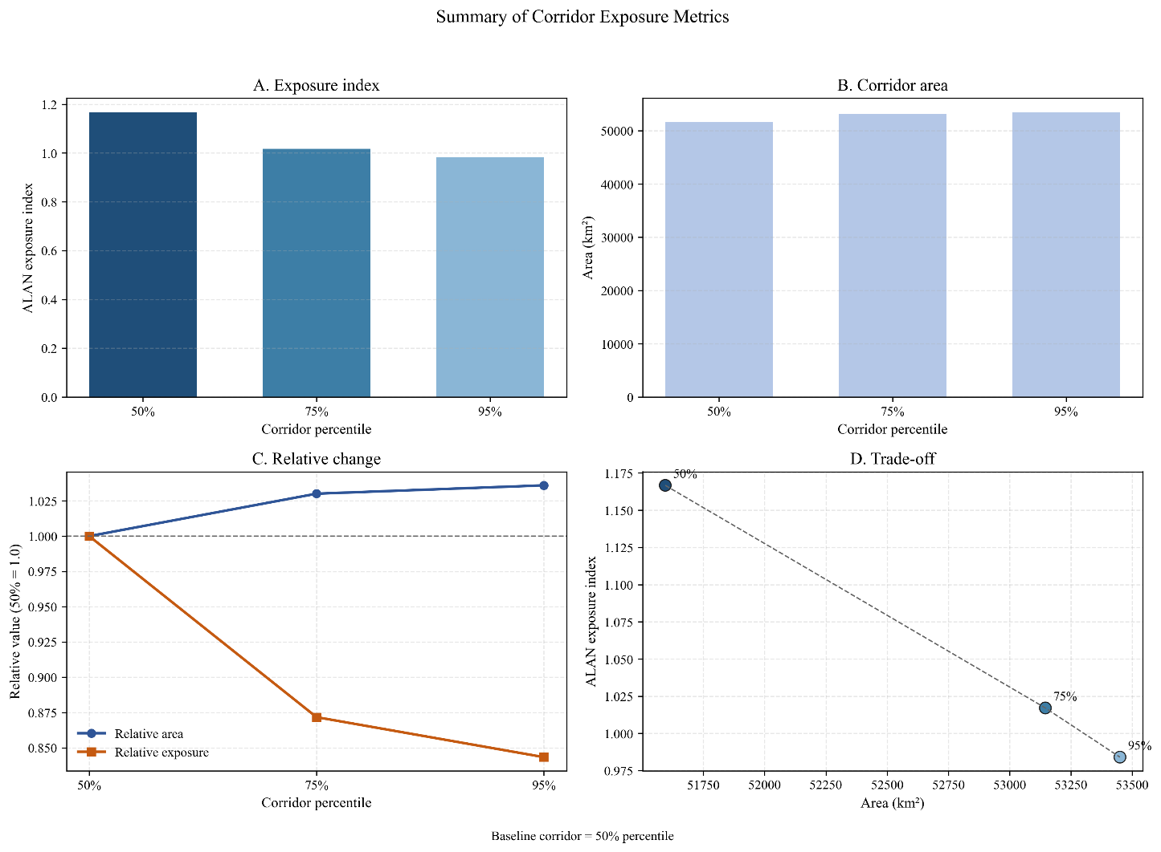
Fig.7. Summary of corridor-scale ALAN exposure indicators.
【Added English】

4.4 Sensitivity and Robustness of Habitat-Exposure Metrics
Habitat-level rankings were highly stable under alternative radiance thresholds and ordinal score functions (Table 6; Fig. 8). STDHNLPI rank correlations with the baseline were 1.000 under the −20% threshold scheme and 0.989 under the +20% scheme; all five highest-STDHNLPI units were retained, and the maximum rank shift was two positions. Under the concave and convex score functions, the corresponding correlations were 0.998 and 0.996, the top-five overlap was 4/5 and 5/5, and the maximum rank shift was one position. Across all nine threshold-by-score scenarios, the minimum correlation was 0.987, at least four of the five highest-exposure units were retained, and the maximum rank shift was two positions. Absolute index values changed more than the rankings, supporting interpretation of STDHNLPI as an operational comparative index rather than a calibrated biological dose.
The key-versus-temporary contrast was also stable across the nine scenarios. STDHNLPI remained higher at key stopovers in every scenario (exact permutation p = 0.0145–0.0287; rank-biserial correlation = 0.667–0.733). Conditional ELS remained directionally higher but was not statistically clear (p = 0.2749–0.5628). These results indicate that the primary habitat-type contrast concerned ALAN coverage and overall standardized exposure, rather than a consistently greater light level within areas already covered by ALAN. Full metric-level results and internal convergence checks are reported in Supplementary Tables S2–S5 and Figs. S1–S2.
Table 6. Robustness of STDHNLPI rankings under alternative radiance thresholds and ordinal class scores.
Sensitivity source | Alternative scheme | Spearman ρ | Top-five overlap | Maximum rank shift
Radiance thresholds | −20% | 1.000 | 5/5 | 0
Radiance thresholds | +20% | 0.989 | 5/5 | 2
Ordinal scores | Concave (γ = 0.5) | 0.998 | 4/5 | 1
Ordinal scores | Convex (γ = 2) | 0.996 | 5/5 | 1
Threshold × score | Nine deterministic scenarios | ≥0.987 | ≥4/5 | ≤2
Note: All values are relative to the baseline thresholds (0.5, 1, 5, and 10 nW cm⁻² sr⁻¹) and the linear normalized score vector (0, 0.25, 0.50, 0.75, 1.00).
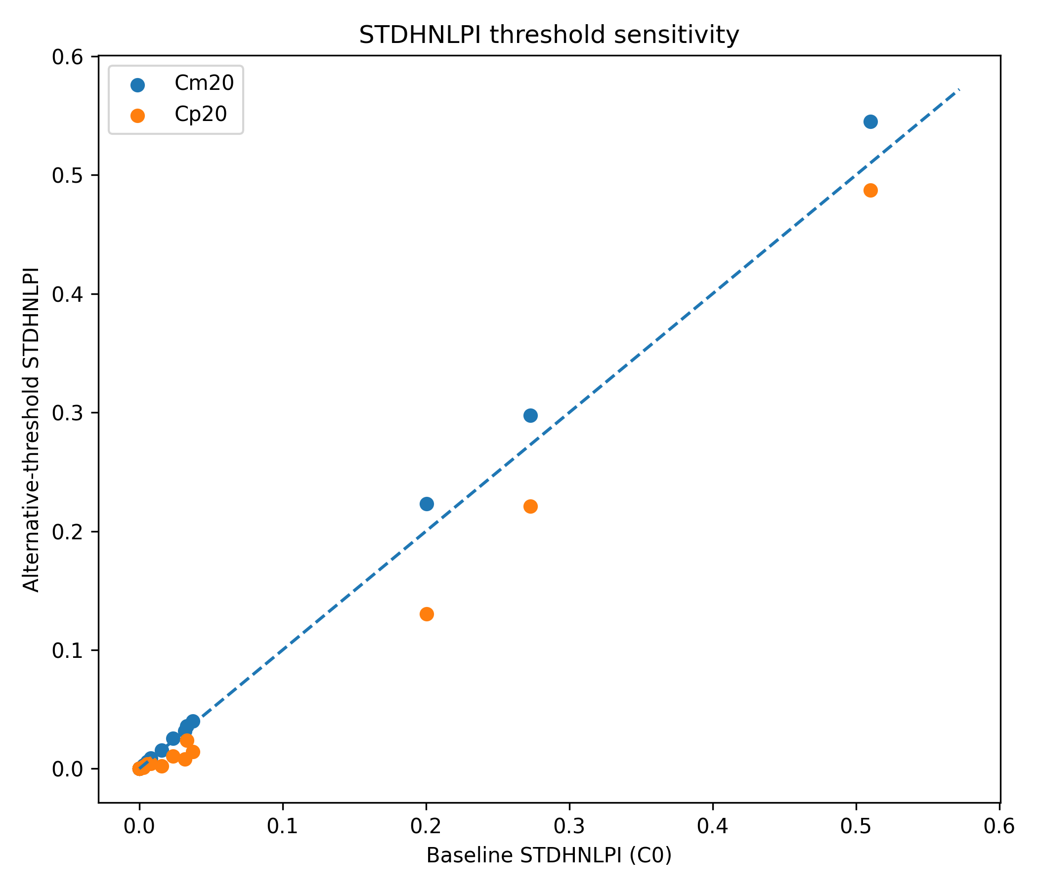
Fig.8. Sensitivity of habitat-level STDHNLPI to ±20% radiance-threshold changes. Points compare each alternative threshold scheme with the baseline; the dashed line denotes 1:1 agreement.
【Added English】

4.5 Annual Sensitivity of Corridor-Scale CEq
The corridor-scale exposure gradient was reproduced in every annual composite (Fig. 9). CEq values for the 50%, 75%, and 95% corridors were 1.0771, 0.9301, and 0.9109 nW cm⁻² sr⁻¹ in 2022; 1.1667, 1.0171, and 0.9840 in 2023; and 1.1507, 0.9988, and 0.9728 in 2024. The ordering 50% > 75% > 95% was therefore invariant across years (Kendall’s W = 1.000), while corridor-specific annual coefficients of variation were only 4.12–4.67%. Relative to the 50% core corridor, CEq was lower by an average of 13.22% in the 75% corridor and 15.51% in the 95% corridor; the between-year standard deviations of these relative reductions were 0.41 and 0.13 percentage points, respectively. Thus, annual background affected absolute CEq magnitude but not the principal core-to-periphery gradient. Full annual and data-quality summaries are provided in Supplementary Table S6 and Figs. S3–S4.
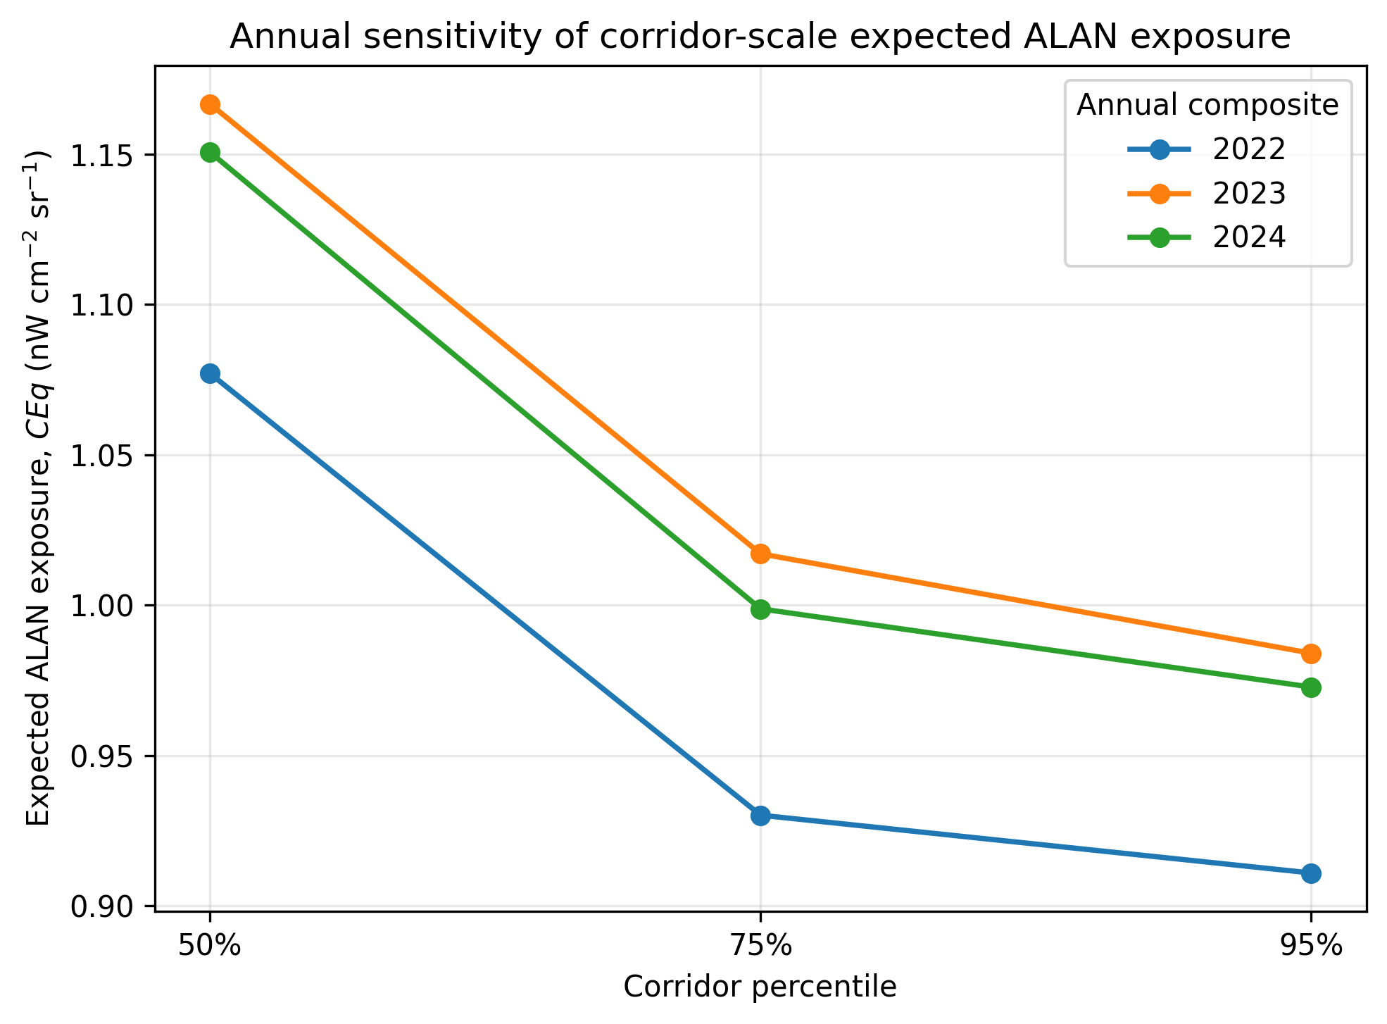
Fig.9. Annual sensitivity of probability-weighted corridor ALAN exposure (CEq) across the 2022–2024 VNP46A4 annual composites. The ordering 50% > 75% > 95% was retained in every year.

5 Discussion

5.1 Differences in ALAN Exposure Among Habitat-Use Types and Their Ecological Implications
【Original English】
One of the most noteworthy results of this study is that key stopover sites were not necessarily the darkest habitat-use units along the tracked migration route. On the contrary, key stopover sites showed higher PCR and STDHNLPI values than temporary stopover sites (Table 3). This should not be interpreted as evidence that Common Cranes prefer bright environments; rather, it more likely indicates that stopover resources of high ecological value are often located in landscapes with stronger human activity (Fig.2, Fig.4), such as river-valley wetlands, reservoir and pond margins, cropland-wetland mosaics, or peri-urban plains. For large migratory waterbirds such as cranes, these areas may simultaneously provide roosting, foraging, and safe resting conditions, thereby generating a spatial pattern in which resource availability and anthropogenic disturbance coexist. Similar coupling between stopover-site selection and human-modified landscapes has been reported for multiple crane species and migratory birds (An and Guo, 2025; Erdenechimeg et al., 2023; Horton et al., 2023; Pearse et al., 2021; Vanausdall et al., 2025).
【Revised English】
One of the most noteworthy results is that key stopover sites were not necessarily the darkest units along the tracked route. Exact permutation tests showed greater ALAN coverage and overall standardized exposure at key than temporary stopovers, but this should not be interpreted as population-level preference for illuminated environments. A more plausible interpretation is spatial co-occurrence: long-used wetlands, reservoir margins, cropland–wetland mosaics, and peri-urban plains may provide food, water, and roosting opportunities while also being embedded in landscapes with greater human activity (Figs. 2 and 4). Broad-scale studies have likewise reported positive associations between skyglow and migrant stopover density, whereas local analyses have found reduced stopover density close to intense light sources (Horton et al., 2023; McLaren et al., 2018).
【Original English】
The difference between key and temporary stopover sites further suggests that habitat-use units with longer residence durations are more likely to be embedded in mixed semi-natural and human-modified nocturnal landscapes. Temporary stopover sites generally occurred in low-coverage, low-intensity dim-light environments, whereas key stopover sites showed higher values in both exposure extent and internal exposure intensity (Fig.6). This indicates that longer stop duration does not necessarily correspond to darker environments; some important stopover sites may continue to be repeatedly used because of superior food resources and water conditions, even when they are adjacent to areas of human activity. From a conservation-management perspective, if priority is given only to the darkest habitat-use units, some repeatedly used stopover nodes experiencing elevated ALAN exposure may be overlooked.
【Revised English】
The corrected conditional ELS analysis refines this interpretation. Temporary stopovers generally had much lower PCR and STDHNLPI, but ELS values overlapped between key and temporary stopovers once units with no detectable ALAN coverage were excluded. The principal contrast was therefore broader ALAN coverage and higher overall exposure at key sites, rather than clearly brighter conditions within portions already illuminated. Longer residence may still reflect favorable foraging or hydrological conditions despite nearby lighting, but the present data cannot determine whether ALAN was tolerated, behaviorally costly, or causally irrelevant. Repeatedly used nodes with elevated exposure should therefore be treated as candidates for field verification rather than evidence of light preference.
【Original English】
The result for the wintering site is also noteworthy. Although only one wintering site was identified in this study, it showed both relatively high coverage and high internal exposure levels (Table 3), suggesting that its ALAN exposure may not come from a few local hotspots, but rather from chronic, persistent background illumination. Given that winter residence duration is much longer than stopover duration, cumulative exposure may potentially exert sustained influences on habitat quality and behavioral rhythms, even if its radiance level does not reach that of an urban core.
【Revised English】
The single wintering site also combined relatively high coverage with moderate conditional intensity (Table 3), indicating that exposure was distributed across a substantial part of the habitat-use unit rather than confined to one isolated hotspot. Because winter residence is prolonged, this site warrants field verification of nightly lighting conditions. However, annual VNP46A4 radiance cannot reconstruct exposure duration, spectrum, weather-mediated skyglow, or cumulative biological dose.

5.2 Different ALAN Exposure Patterns Between Habitat-Use Units and High-Use Corridors
【Original English】
In addition to differences among habitat-use types, this study also found that ALAN exposure patterns differed between the habitat-use units and high-use migration corridors scale. At the habitat-use-unit scale, most sites were still dominated by the near-background or very low-light 0-0.5 class, and only some key stopover sites and the wintering site showed high ALAN exposure (Fig.4). At the corridor scale, however, probability-weighted expected ALAN exposure remained relatively high across all three corridor levels and was highest in the 50% core corridor (Fig.7). This indicates that the most intensively used migration path did not necessarily correspond to the darkest route band, but may instead spatially overlap with relatively brighter coastal, plain, or human-modified corridors.
【Revised English】
ALAN exposure also differed between habitat-use units and movement corridors. At the habitat scale, most polygons were dominated by the 0–0.5 nW cm⁻² sr⁻¹ near-background class, with elevated exposure concentrated in several key stopovers and the wintering site. At the corridor scale, probability-weighted expected radiance remained near 1 nW cm⁻² sr⁻¹ across the nested envelopes and was highest in the 50% core corridor. The two scales answer different questions: habitat metrics characterize exposure during residence, whereas CEq characterizes radiance along repeatedly used movement space.
【Original English】
This result should not be interpreted simplistically as active attraction of Common Cranes toward bright light during migration. The overlap between the core corridor and brighter areas may reflect the joint constraints of topography, wind fields, wetland distribution, and avoidance of movement barriers. Regardless of whether this overlap reflects active selection or external constraints, it remains ecologically relevant. Previous studies have shown that ALAN can affect migratory birds through mechanisms such as attraction, disorientation, alteration of flight height, and aggregation of migratory activity near artificial environments(Burt et al., 2023; Hirschhofer et al., 2026; Horton et al., 2023). In this study, as the corridor expanded from the 50% core zone to the 95% overall zone, area increased only slightly whereas exposure decreased substantially, indicating that the most repeatedly used portions of the migration route do not correspond to the lowest ALAN exposure.
【Revised English】
The brighter core-corridor overlap should not be interpreted as active attraction to ALAN. Route concentration may arise from topography, winds, wetland distribution, coastlines, human land use, or avoidance of other barriers. Nevertheless, the overlap is ecologically relevant because illuminated patches can alter orientation, flight behavior, aggregation, and collision risk in some migratory birds, including at relatively low coastal light levels (Burt et al., 2023; Hirschhofer et al., 2026; Horton et al., 2023). The fact that area changed little while expected radiance declined substantially toward the 95% envelope suggests that the most repeatedly used route cells were also relatively bright. It does not reveal whether lighting caused, constrained, or merely coincided with route use.
The annual sensitivity analysis strengthens the corridor-scale interpretation. Although absolute CEq values were lower in 2022 and slightly lower in 2024 than in 2023, the 50% > 75% > 95% ordering was invariant and the normalized 75%/50% and 95%/50% ratios varied by less than 0.5% across years. Thus, using the 2023 composite did not create the core-corridor gradient, although numerical CEq values should still be reported with the annual product used.
【Original English】
This difference indicates that habitat-use units and migration corridors require different exposure metrics. For habitat-use units, where birds remain for relatively long periods, exposure extent, exposure intensity, and internal structure should all be considered. For migration corridors, where birds are in transit, probability-weighted expected exposure is more appropriate. Applying the same simple indicator to both would weaken ecological interpretability and make it difficult to distinguish between “stopover exposure” and “transit exposure.”
【Revised English】
These scale-specific patterns justify the use of different metrics. For residence units, PCR, STDHNLPI, HER, and ELS jointly separate exposure extent, overall weighted intensity, bright-pixel prevalence, and intensity within the lit portion. For transit corridors, a probability-weighted expected radiance is more appropriate because exposure depends on where movement is concentrated within the corridor. Applying a single mean-radiance statistic to both scales would obscure the distinction between stopover exposure and transit exposure and could produce misleading management priorities.

5.3 Potential Ecological Implications and Anthropogenic Drivers
【Original English】
From the perspective of potential ecological implications, the widespread low- to moderate-intensity ALAN in key stopover sites and the wintering site may influence nighttime behavior, vigilance, sleep rhythms, and habitat-use patterns of Common Cranes and associated bird species through chronic exposure (Fig.5). Although most habitat-use units did not exhibit high proportions of the 5-10 or >10 classes, this does not indicate negligible ecological concern, because previous studies have shown that birds can exhibit behavioral and physiological responses to relatively weak ALAN (Adams et al., 2024; Beaugeard et al., 2024; Dominoni et al., 2013; Raap et al., 2015; Sanders et al., 2021). The overlap between the core migration corridor and brighter nighttime landscapes may increase the potential for altered orientation, aggregation, or collision risk in artificially lit environments.
【Revised English】
Widespread low-to-moderate ALAN at key stopovers and the wintering site may be relevant to vigilance, sleep, activity timing, and habitat use, because avian responses have been reported even below urban-core radiance levels (Adams et al., 2024; Beaugeard et al., 2024; Dominoni et al., 2013; Raap et al., 2015; Sanders et al., 2021). Likewise, overlap between the core corridor and brighter landscapes may indicate locations where orientation or collision hazards deserve investigation. However, the present study measured remotely sensed exposure potential, not behavior, physiology, collisions, survival, or fitness.
【Original English】
From the perspective of landscape drivers, key stopover sites and the wintering site with relatively high ALAN exposure were mostly located in cropland-wetland mosaics, river-lake margins, or plains with more intense human activity (Fig.2, Fig.4). These areas are usually accompanied by roads, villages, industrial facilities, aquaculture areas, and linear infrastructure, and ALAN is one of the most readily detectable manifestations of such disturbance using remote sensing. In other words, in these areas ALAN is unlikely to act in isolation, but rather as part of a compound disturbance together with land-use change, noise, human activity, and landscape fragmentation. Recent research has increasingly emphasized that ALAN should be understood within a broader framework of sensory pollution and ecological-network rewiring, rather than being viewed solely as a lighting issue (Johnston et al., 2025; McCloy et al., 2024; Orlando et al., 2026; Sanders et al., 2023).
【Revised English】
The relatively exposed key stopovers and wintering site occurred mainly in cropland-wetland mosaics, river-lake margins, and plains with stronger human activity (Fig. 2, Fig. 4). Roads, settlements, industrial facilities, aquaculture, noise, land-cover change, and linear infrastructure may covary with nighttime radiance. ALAN should therefore be regarded both as a disturbance and as one remotely detectable component of a broader human footprint. This confounding prevents the present overlay analysis from isolating an independent causal effect of light. It also supports a compound-disturbance perspective in which sensory pollution and landscape fragmentation jointly reshape ecological networks (Johnston et al., 2025; McCloy et al., 2024; Orlando et al., 2026; Sanders et al., 2023).
【Original English】
From a management perspective, habitat-use units with simultaneously high PCR and ELS could be considered priority areas for ALAN management (Fig.6), where nighttime disturbance could be reduced by lowering lighting intensity, shortening lighting duration, adding shielding devices, and restricting new light sources. For sites with low PCR but high ELS, local hotspots of strong illumination should be specifically investigated. For corridors, priority should be given to route sections where high-use bottlenecks overlap with areas of elevated ALAN exposure, because even if such areas are small, they may affect a large proportion of migratory activity.
【Revised English】
From a management perspective, the framework supports a tiered screening strategy rather than immediate intervention based on radiance alone. High-use units with high PCR or STDHNLPI should first receive field audits of light-source type, timing, spectrum, shielding, crane use, and habitat quality. Units with low PCR but high ELS warrant targeted investigation of localized hotspots, whereas broad high-PCR exposure may require landscape-scale coordination. Feasible measures can include full-cutoff shielding, lower intensity, seasonal or nightly curfews, avoidance of new light sources, and maintenance of dark buffers around roosts and movement bottlenecks. Corridor management should prioritize narrow high-use sections where elevated CEq overlaps with infrastructure, followed by before–after monitoring and adaptation to local ecological and safety requirements (Sordello et al., 2022).

5.4 Limitations and Future Directions
【Original English】
This study has several limitations. First, the analysis was based on a single tracked Common Crane individual, which limits the generalization of the identified habitat-use units and migration corridors to the population level. However, this limitation reflects practical and conservation-related constraints rather than arbitrary sampling. The Common Crane is a Class II nationally protected wild animal in China, and intentional capture and transmitter deployment are highly restricted; therefore, long-term tracking opportunities mainly depend on rescued individuals. Continuous multi-year tracking records for large migratory birds are also difficult to obtain because of device failure, tag loss, limited battery life, and individual mortality. Although other rescued migratory birds were fitted with transmitters, their tracking durations were generally less than one year and did not cover a complete annual cycle, making them unsuitable for route-scale assessment of ALAN exposure. In contrast, the Common Crane used in this study generated a two-year dataset with more than 17,000 location fixes, covering breeding, migratory stopover, and wintering phases. The two annual tracks showed broadly similar route patterns, suggesting that this individual record provides useful insight into repeated route use and route-scale exposure patterns. Nevertheless, the results should be interpreted as an individual-level route representation rather than a population-level utilization distribution. Second, VNP46A4 is an annual nighttime-light composite product with a spatial resolution of about 500 m. It is suitable for broad route-scale comparisons, but it cannot capture monthly or daily changes in lighting, nor can it reflect light spectrum, directional shielding, or the actual illuminated conditions at the GPS-point scale. If future work focuses on fine-scale exposure processes during stopovers, monthly or daily products with higher spatial resolution would be more appropriate. Third, the classification of breeding and wintering sites relied mainly on stop duration and seasonal windows, without incorporating climate, phenology, or independent ground observations; ecological interpretation therefore still bears the simplification of rule-based classification. Finally, the nighttime-light classes used here are operational remote-sensing exposure categories rather than Common Crane-specific physiological thresholds. Future studies should combine multi-year, multi-individual trajectories and field observations to further test the robustness of the conclusions under different threshold and weighting schemes.
【Revised English】
The most important limitation is the use of one rescued adult male. The Common Crane is a Class II nationally protected species in China, and purposeful capture for scientific research requires special authorization (Standing Committee of the National People's Congress of the People's Republic of China, 2022). In this project, transmitter deployment opportunities arose through authorized rescue rather than repeated capture designed to build a conventional sample, and other rescued birds did not yield complete annual tracks. The framework was therefore tailored to extract a standardized individual-route assessment from a rare, long-duration, high-frequency record by emphasizing temporal continuity and elapsed residence duration. This addresses an analytical problem created by data scarcity; it does not solve biological replication. Common Cranes commonly migrate and winter in groups, so an individual route may identify candidate features of a socially used movement landscape. However, flock membership was not observed, and gregariousness cannot justify treating one track as representative of a flock or population.
The sensitivity analyses strengthen method-level robustness within this observed route. Habitat rankings and priority-unit identification were stable under ±20% radiance-threshold changes and alternative ordinal score functions, and the corridor gradient persisted across the 2022–2024 annual composites. These analyses show that the principal exposure patterns were not artifacts of one class boundary, one equal-interval score vector, or one annual composite. They remain internal robustness checks, however: all radiance measures derive from VNP46A4, and no independent individuals, ground-based light measurements, or behavioral controls were available. Moreover, correct treatment of ELS showed that the key-versus-temporary difference was driven mainly by coverage and overall exposure, not by a clearly greater conditional intensity. The framework is therefore reproducible and internally robust at the individual-route scale, but not externally validated at the population scale.
Further limitations concern causal interpretation and spatial-temporal resolution. The design is observational, so overlap between route use and radiance cannot establish attraction, avoidance, impairment, or fitness effects. VNP46A4 is an annual composite on a nominal approximately 500-m grid; mixed pixels can combine illuminated and dark surfaces, and the product cannot resolve individual lamps, shielding, spectrum, weather-dependent skyglow, or the lighting present at each GPS timestamp. Habitat labels were assigned using chronological and duration rules and checked against land cover, but independent field confirmation was unavailable. The radiance classes are operational exposure categories rather than Common Crane physiological thresholds. Future work should add permitted multi-individual tracking when rescue or authorized research opportunities arise, independent field light measurements, behavioral or altitude sensors, and finer-temporal radiance products.

6 Conclusion
【Original English】
This study established a route-scale analytical framework integrating T-DBSCAN habitat-use identification, extraction of high-use migration corridors, and Black Marble ALAN exposure assessment to quantify ALAN exposure in habitat-use units and corridors during Common Crane migration. A total of 18 habitat-use units were identified, Exploratory comparisons indicated that key stopover sites had higher ALAN coverage and standardized pollution levels than temporary stopover sites. The combined use of STDHNLPI, PCR, HER, and ELS effectively distinguished two different exposure structures: “large-area low light” and “small-area high light.” At the corridor scale, the 50% core corridor exhibited the highest expected ALAN exposure, whereas the 75% and 95% corridors showed only slight increases in area but substantially lower exposure. This indicates stronger spatial overlap between the most repeatedly used Common Crane migration paths and brighter nighttime landscapes.
【Revised English】
Using more than 17,000 fixes from one rescued adult male Common Crane, this study integrated duration-aware T-DBSCAN habitat identification, nested corridor extraction, and Black Marble radiance to quantify residence and transit exposure along an observed route. Eighteen habitat-use units were identified: one breeding site, one wintering site, six key stopovers, and ten temporary stopovers. Key stopovers showed greater ALAN coverage and overall standardized exposure than temporary stopovers, whereas conditional intensity within ALAN-covered areas and the high-radiance proportion showed no clear group differences. Habitat-exposure rankings remained highly stable under alternative radiance thresholds and ordinal scoring assumptions, with a maximum rank shift of two positions.
【Original English】
Overall, ALAN exposure varies not only among different habitat-use types, but also between habitat-use units and migration corridors. Conservation of migratory birds should therefore focus not only on fixed habitat-use units, but also on high-use migration bottlenecks as key targets for ALAN management and ecological protection.
【Revised English】
The 50% core corridor had the highest 2023 CEq, and the 50% > 75% > 95% ordering persisted across the 2022–2024 annual composites. Annual background affected absolute CEq magnitude but not the core-to-periphery exposure gradient. These findings identify candidate habitat nodes and movement bottlenecks for field verification and targeted lighting audits; they do not demonstrate population-level habitat selection or causal effects of ALAN. The principal contribution is a reproducible screening framework for rare, high-quality individual tracks that preserves the need for additional individuals and independent field validation.

Acknowledgements
This work was supported by the National Natural Science Foundation of China (Grant No. 32571810). The funder had no role in the study design, data collection and analysis, interpretation of results, preparation of the manuscript, or the decision to submit the article for publication.

Declaration of generative AI and AI-assisted technologies in the manuscript preparation process
During the preparation of the revised manuscript, the authors used ChatGPT (OpenAI) to assist with English-language editing, manuscript restructuring, and drafting of sensitivity-analysis code and reporting text. The authors are responsible for independently rerunning and verifying the analytical outputs, figures, tables, references, interpretations, and conclusions before submission and take full responsibility for the final content of the publication.

Data and Code Availability
Analysis code, parameter files, a one-year example GPS dataset, and instructions for acquiring the Dynamic World and NASA Black Marble VNP46A4 inputs are available at https://github.com/BiLiangXin/common_crane. The complete two-year high-resolution GPS record is not posted openly because it contains sensitive locations of a nationally protected wild animal and is subject to data-provider requirements; controlled access may be requested from the corresponding author. The non-sensitive derived data used for the revised analyses are supplied with this submission as Supplementary Data S1–S3, and the corresponding habitat-robustness and corridor annual-sensitivity scripts are supplied as Supplementary Code S1–S2. Supplementary Tables S1–S6 and Figs. S1–S4 provide complete scenario definitions, unit-level robustness results, exact group comparisons, internal consistency checks, and annual CEq summaries. Before resubmission, the authors should upload the same non-sensitive files to a versioned repository release and replace this sentence with the permanent release identifier.

References

Adams, C.A., Clair, C.C.S., Knight, E.C. and Bayne, E.M., 2024. Behaviour and landscape contexts determine the effects of artificial light on two crepuscular bird species. Landsc Ecol. 39, 83. https://doi.org/10.1007/s10980-024-01875-3.
Alavi, S.E., Vining, A.Q., Caillaud, D., Hirsch, B.T., Havmøller, R.W., Havmøller, L.W., et al., 2022. A Quantitative Framework for Identifying Patterns of Route-Use in Animal Movement Data. Frontiers in Ecology and Evolution. 9. https://doi.org/10.3389/fevo.2021.743014.
An, J. and Guo, Y., 2025. Characteristics of important migratory stopover sites of black-necked cranes on the Tibetan plateau. Global Ecology and Conservation. 64. https://doi.org/10.1016/j.gecco.2025.e03950.
Baert, J.M., Stienen, E.W.M., Heylen, B.C., Kavelaars, M.M., Buijs, R.J., Shamoun-Baranes, J., et al., 2018. High-resolution GPS tracking reveals sex differences in migratory behaviour and stopover habitat use in the Lesser Black-backed Gull Larus fuscus. Sci Rep. 8, 5391. https://doi.org/10.1038/s41598-018-23605-x.
Beaugeard, E., Brischoux, F. and Angelier, F., 2024. Light pollution affects activity differentially across breeding stages in an urban exploiter: An experiment in the house sparrow (Passer domesticus). Environ Pollut. 351, 124055. https://doi.org/10.1016/j.envpol.2024.124055.
Benhammou, Y., Alcaraz-Segura, D., Guirado, E., Khaldi, R., Achchab, B., Herrera, F., et al., 2022. Sentinel2GlobalLULC: A Sentinel-2 RGB image tile dataset for global land use/cover mapping with deep learning. Sci Data. 9, 681. https://doi.org/10.1038/s41597-022-01775-8.
Birant, D. and Kut, A., 2007. ST-DBSCAN: An algorithm for clustering spatial–temporal data. Data & Knowledge Engineering. 60, 208–221. https://doi.org/10.1016/j.datak.2006.01.013.
Bridge, E.S., Thorup, K., Bowlin, M.S., Chilson, P.B., Diehl, R.H., Fléron, R.W., et al., 2011. Technology on the Move: Recent and Forthcoming Innovations for Tracking Migratory Birds. BioScience. 61, 689–698. https://doi.org/10.1525/bio.2011.61.9.7.
Brown, C.F., Brumby, S.P., Guzder-Williams, B., Birch, T., Hyde, S.B., Mazzariello, J., et al., 2022. Dynamic World, Near real-time global 10 m land use land cover mapping. Scientific Data. 9. https://doi.org/10.1038/s41597-022-01307-4.
Burt, C.S., Kelly, J.F., Trankina, G.E., Silva, C.L., Khalighifar, A., Jenkins-Smith, H.C., et al., 2023. The effects of light pollution on migratory animal behavior. Trends Ecol Evol. 38, 355–368. https://doi.org/10.1016/j.tree.2022.12.006.
Demšar, U., Long, J.A., Benitez-Paez, F., Brum Bastos, V., Marion, S., Martin, G., et al., 2021. Establishing the integrated science of movement: bringing together concepts and methods from animal and human movement analysis. International Journal of Geographical Information Science. 35, 1273–1308. https://doi.org/10.1080/13658816.2021.1880589.
Ditmer, M.A., Stoner, D.C. and Carter, N.H., 2021. Estimating the loss and fragmentation of dark environments in mammal ranges from light pollution. Biological Conservation. 257. https://doi.org/10.1016/j.biocon.2021.109135.
Dominoni, D., Quetting, M. and Partecke, J., 2013. Artificial light at night advances avian reproductive physiology. Proc Biol Sci. 280, 20123017. https://doi.org/10.1098/rspb.2012.3017.
Erdenechimeg, B., Purev-Ochir, G., Gungaa, A., Terbish, O., Zhao, Y. and Guo, Y., 2023. Migration Pattern, Habitat Use, and Conservation Status of the Eastern Common Crane (Grus grus lilfordi) from Eastern Mongolia. Animals (Basel). 13. https://doi.org/10.3390/ani13142287.
Falchi, F., Cinzano, P., Duriscoe, D., Kyba, C.C., Elvidge, C.D., Baugh, K., et al., 2016. The new world atlas of artificial night sky brightness. Sci Adv. 2, e1600377. https://doi.org/10.1126/sciadv.1600377.
Fischer, C., 2024. Challenges and opportunities when studying movement ecology in science and practical conservation. Basic and Applied Ecology. 81, 59–65. https://doi.org/10.1016/j.baae.2024.10.006.
Foppen, K., Pinxten, R., Meijdam, M. and Eens, M., 2024. Artificial Light at Night Advances the Onset of Vocal Activity in Both Male and Female Great Tits During the Breeding Season, While Noise Pollution Has Less Impact and Only in Females. Animals (Basel). 14. https://doi.org/10.3390/ani14223199.
Gaston, K.J., Ackermann, S., Bennie, J., Cox, D.T.C., Phillips, B.B., Sanchez de Miguel, A., et al., 2021. Pervasiveness of Biological Impacts of Artificial Light at Night. Integr Comp Biol. 61, 1098–1110. https://doi.org/10.1093/icb/icab145.
Gould, L.A., Manning, A.D., McGinness, H.M. and Hansen, B.D., 2024. A review of electronic devices for tracking small and medium migratory shorebirds. Animal Biotelemetry. 12. https://doi.org/10.1186/s40317-024-00368-z.
Gupte, P.R., Beardsworth, C.E., Spiegel, O., Lourie, E., Toledo, S., Nathan, R., et al., 2022. A guide to pre-processing high-throughput animal tracking data. J Anim Ecol. 91, 287–307. https://doi.org/10.1111/1365-2656.13610.
He, X., Liu, X., Liu, J., Li, Y., Xu, Z., Mo, P., et al., 2025. The T-DBSCAN Algorithm for Stopover Site Identification of Migration Birds Based on Satellite Positioning Data. Biology (Basel). 14. https://doi.org/10.3390/biology14030277.
Hirschhofer, S., Ranacher, P., Weibel, R., Helm, B., Ćiković, D., Barišić, S., et al., 2026. When nocturnally migrating birds encounter low-level light pollution patches: a case study from the Croatian coast. Biological Conservation. 313. https://doi.org/10.1016/j.biocon.2025.111620.
Horton, K.G., Buler, J.J., Anderson, S.J., Burt, C.S., Collins, A.C., Dokter, A.M., et al., 2023. Artificial light at night is a top predictor of bird migration stopover density. Nat Commun. 14, 7446. https://doi.org/10.1038/s41467-023-43046-z.
Huang, C., Ye, Y., Jin, Y. and Liang, B., 2023. Research Progress, Hotspots, and Evolution of Nighttime Light Pollution: Analysis Based on WOS Database and Remote Sensing Data. Remote Sensing. 15. https://doi.org/10.3390/rs15092305.
Iverson, A.R., Schaefer, J.L.B., Skalos, S.M. and Hawkins, C.E., 2023. Global positioning system (GPS) and platform transmitter terminal (PTT) tags reveal fine-scale migratory movements of small birds: A review highlights further opportunities for hypothesis-driven research. Ornithological Applications. 125. https://doi.org/10.1093/ornithapp/duad014.
Johnston, A.S.A., Kim, J. and Harris, J.A., 2025. Widespread influence of artificial light at night on ecosystem metabolism. Nat Clim Chang. 15, 1371–1377. https://doi.org/10.1038/s41558-025-02481-0.
Koger, B., Deshpande, A., Kerby, J.T., Graving, J.M., Costelloe, B.R. and Couzin, I.D., 2023. Quantifying the movement, behaviour and environmental context of group-living animals using drones and computer vision. J Anim Ecol. 92, 1357–1371. https://doi.org/10.1111/1365-2656.13904.
Kölzsch, A., Müskens, G.J.D.M., Kruckenberg, H., Glazov, P., Weinzierl, R., Nolet, B.A., et al., 2016. Towards a new understanding of migration timing: slower spring than autumn migration in geese reflects different decision rules for stopover use and departure. Oikos. 125, 1496–1507. https://doi.org/10.1111/oik.03121.
Korpach, A.M., Garroway, C.J., Mills, A.M., von Zuben, V., Davy, C.M. and Fraser, K.C., 2022. Urbanization and artificial light at night reduce the functional connectivity of migratory aerial habitat. Ecography. 2022. https://doi.org/ARTN e05581
10.1111/ecog.05581.
Kyba, C.C.M., Kuester, T., Sanchez de Miguel, A., Baugh, K., Jechow, A., Holker, F., et al., 2017. Artificially lit surface of Earth at night increasing in radiance and extent. Sci Adv. 3, e1701528. https://doi.org/10.1126/sciadv.1701528.
Levin, N., Kyba, C.C.M., Zhang, Q., Sánchez de Miguel, A., Román, M.O., Li, X., et al., 2020. Remote sensing of night lights: A review and an outlook for the future. Remote Sensing of Environment. 237. https://doi.org/10.1016/j.rse.2019.111443.
Li, D., Liu, K., Gao, Y.X., Wu, Y. and Hou, X.Y., 2024. Stopover habitat use of coastal Pied Avocet revealed by satellite tracking and remote sensing technology. Global Ecology and Conservation. 56. https://doi.org/ARTN e03290
10.1016/j.gecco.2024.e03290.
Li, J., Qian, F., Zhang, Y., Zhao, L., Deng, W. and Ma, K., 2023. Identifying seasonal differences in migration characteristics of Oriental white stork (Ciconia boyciana) through satellite tracking and remote sensing. Ecological Indicators. 146. https://doi.org/10.1016/j.ecolind.2022.109760.
Li, T., Zhu, Z., Wang, Z., Román, M.O., Kalb, V.L. and Zhao, Y., 2022. Continuous monitoring of nighttime light changes based on daily NASA's Black Marble product suite. Remote Sensing of Environment. 282. https://doi.org/10.1016/j.rse.2022.113269.
Longcore, T. and Rich, C., 2004. Ecological light pollution. Frontiers in Ecology and the Environment. 2, 191–198. https://doi.org/10.1890/1540-9295(2004)002[0191:Elp]2.0.Co;2.
Matics, E., Laczi, M., Schneider, Z., Hoffmann, G. and Matics, R., 2025. Artificial light at night (ALAN) negatively affects nest site occupancy but does not influence breeding success in two sympatric owl species. Sci Rep. 15, 38234. https://doi.org/10.1038/s41598-025-22044-9.
McCloy, M.W.D., Andringa, R.K., Maness, T.J., Smith, J.A. and Grace, J.K., 2024. Promoting urban ecological resilience through the lens of avian biodiversity. Frontiers in Ecology and Evolution. 12. https://doi.org/10.3389/fevo.2024.1302002.
McLaren, J.D., Buler, J.J., Schreckengost, T., Smolinsky, J.A., Boone, M., Emiel van Loon, E., et al., 2018. Artificial light at night confounds broad-scale habitat use by migrating birds. Ecol Lett. 21, 356–364. https://doi.org/10.1111/ele.12902.
Nam, H.K., Kim, H.J., Davaasuren, B., Natsagdorj, T., Batbayar, N., Nergui, J., et al., 2025. Migration and population characteristics of white-naped cranes wintering on the Korean Peninsula. Sci Rep-Uk. 15. https://doi.org/ARTN 18785
10.1038/s41598-025-03478-7.
National Forestry and Grassland Administration and Ministry of Agriculture and Rural Affairs, 2021. List of State Key Protected Wild Animals. In: National Forestry and Grassland Administration; Ministry of Agriculture and Rural Affairs, Beijing, China, pp. 11.
Orlando, G., Nelli, L., Baker, P., Karell, P., Vrezec, A., Treinys, R., et al., 2026. Sensory pollutants have negative but different effects on nestbox occupancy and breeding performance of a nocturnal raptor across Europe. Biological Conservation. 313. https://doi.org/10.1016/j.biocon.2025.111533.
Pearse, A.T., Metzger, K.L., Brandt, D.A., Shaffer, J.A., Bidwell, M.T. and Harrell, W., 2021. Migrating Whooping Cranes avoid wind-energy infrastructure when selecting stopover habitat. Ecol Appl. 31, e02324. https://doi.org/10.1002/eap.2324.
Raap, T., Pinxten, R. and Eens, M., 2015. Light pollution disrupts sleep in free-living animals. Sci Rep. 5, 13557. https://doi.org/10.1038/srep13557.
Román, M.O., Wang, Z., Sun, Q., Kalb, V., Miller, S.D., Molthan, A., et al., 2018. NASA's Black Marble nighttime lights product suite. Remote Sensing of Environment. 210, 113–143. https://doi.org/10.1016/j.rse.2018.03.017.
Sanders, D., Frago, E., Kehoe, R., Patterson, C. and Gaston, K.J., 2021. A meta-analysis of biological impacts of artificial light at night. Nat Ecol Evol. 5, 74–81. https://doi.org/10.1038/s41559-020-01322-x.
Sanders, D., Hirt, M.R., Brose, U., Evans, D.M., Gaston, K.J., Gauzens, B., et al., 2023. How artificial light at night may rewire ecological networks: concepts and models. Philos Trans R Soc Lond B Biol Sci. 378, 20220368. https://doi.org/10.1098/rstb.2022.0368.
Scarpignato, A.L., Huysman, A.E., Jimenez, M.F., Witko, C.J., Harrison, A.-L., Seavy, N.E., et al., 2023. Shortfalls in tracking data available to inform North American migratory bird conservation. Biological Conservation. 286. https://doi.org/10.1016/j.biocon.2023.110224.
Schmaljohann, H. and Eikenaar, C., 2017. How do energy stores and changes in these affect departure decisions by migratory birds? A critical view on stopover ecology studies and some future perspectives. J Comp Physiol A Neuroethol Sens Neural Behav Physiol. 203, 411–429. https://doi.org/10.1007/s00359-017-1166-8.
Schmaljohann, H., Eikenaar, C. and Sapir, N., 2022. Understanding the ecological and evolutionary function of stopover in migrating birds. Biol Rev Camb Philos Soc. 97, 1231–1252. https://doi.org/10.1111/brv.12839.
Shariatinajafabadi, M., Wang, T., Skidmore, A.K., Toxopeus, A.G., Kolzsch, A., Nolet, B.A., et al., 2014. Migratory herbivorous waterfowl track satellite-derived green wave index. PLoS One. 9, e108331. https://doi.org/10.1371/journal.pone.0108331.
Sordello, R., Busson, S., Cornuau, J.H., Deverchère, P., Faure, B., Guetté, A., et al., 2022. A plea for a worldwide development of dark infrastructure for biodiversity - Practical examples and ways to go forward. Landscape Urban Plan. 219. https://doi.org/ARTN 104332
10.1016/j.landurbplan.2021.104332.
Sung, C.Y., 2022. Light pollution as an ecological edge effect: Landscape ecological analysis of light pollution in protected areas in Korea. Journal for Nature Conservation. 66. https://doi.org/10.1016/j.jnc.2022.126148.
Van Doren, B.M., Horton, K.G., Dokter, A.M., Klinck, H., Elbin, S.B. and Farnsworth, A., 2017. High-intensity urban light installation dramatically alters nocturnal bird migration. Proc Natl Acad Sci U S A. 114, 11175–11180. https://doi.org/10.1073/pnas.1708574114.
Vanausdall, R., Kendall, W., Collins, D., Donnelly, J. and Hays, Q., 2025. Habitat selection by Rocky Mountain Population greater Sandhill Cranes ( Antigone canadensis tabida ) during spring and autumn migration at a key stopover area. Avian Conservation and Ecology. 20. https://doi.org/10.5751/ace-02924-200214.
Wang, D., Miwa, T. and Morikawa, T., 2020. Big Trajectory Data Mining: A Survey of Methods, Applications, and Services. Sensors (Basel). 20. https://doi.org/10.3390/s20164571.
Wang, K., Pang, L. and Li, X., 2023. Identification of Stopping Points in GPS Trajectories by Two-Step Clustering Based on DPCC with Temporal and Entropy Constraints. Sensors (Basel). 23. https://doi.org/10.3390/s23073749.
Wang, Z., Shrestha, R.M., Roman, M.O. and Kalb, V.L., 2022. NASA’s Black Marble Multiangle Nighttime Lights Temporal Composites. IEEE Geoscience and Remote Sensing Letters. 19, 1–5. https://doi.org/10.1109/lgrs.2022.3176616.
Wen, L., Purev-Ochir, G., Erdenechimeg, B., Khurelbaatar, D., Li, X., Li, X., et al., 2026. Satellite tracking reveals a migratory divide and population-specific migratory strategies in White-naped Cranes. Avian Research. 17. https://doi.org/10.1016/j.avrs.2025.100324.
Xu, P., Tsendbazar, N.-E., Herold, M., de Bruin, S., Koopmans, M., Birch, T., et al., 2024. Comparative validation of recent 10 m-resolution global land cover maps. Remote Sensing of Environment. 311. https://doi.org/10.1016/j.rse.2024.114316.
Yi, K.P., Zhang, J.J., Batbayar, N., Higuchi, H., Natsagdorj, T. and Bysykatova, I.P., 2022. Using Tracking Data to Identify Gaps in Knowledge and Conservation of the Critically Endangered Siberian Crane (
). Remote Sensing. 14. https://doi.org/ARTN 5101
10.3390/rs14205101.
Zhang, X., Liu, L., Zhao, T., Zhang, W., Guan, L., Bai, M., et al., 2025. GLC_FCS10: a global 10 m land-cover dataset with a fine classification system from Sentinel-1 and Sentinel-2 time-series data in Google Earth Engine. Earth System Science Data. 17, 4039–4062. https://doi.org/10.5194/essd-17-4039-2025.
Zheng, Y., 2015. Trajectory Data Mining. ACM Transactions on Intelligent Systems and Technology. 6, 1–41. https://doi.org/10.1145/2743025.

